Technical Setup and reference guide



Showcases technical skills in setting up and installing operating systems, virtual machines, and more.

Destiny Clay

08/22/2024

Contents

Operating Systems 3

Downloading a Windows 10 and 11 ISO File 3

Downloading an openSUSE and Ubuntu ISO File 10

Creating a New User in Windows 10 15

Creating a Local Group in Windows 10 and Adding Users 20

Creating a Network Share and Using NTFS Permissions 31

Virtual Machines 45

Creating Windows 10 and 11 Virtual Machines 45

Creating openSUSE and Ubuntu Virtual Machines 69

Windows 10 Personalization 77

Using Windows 10 Registry Editor to Pause Updates 77

## Operating Systems

### Downloading a Windows 10 and 11 ISO File

**Step 1: Make sure your computer can handle the operating system**

Windows 10 has specific hardware requirements for installation.

* Processor: 1 GHz
* RAM: 2GB
* Hard disk space: 20GB

A good way to tell what kind of hardware your computer has is using task manager. Task manager provides information about the running applications, general performance, and hardware of the computer.

**Opening task manager:**

Task manager can be opened several ways, but for this example we will use what I consider the easiest.

Navigate down to your task bar, the task bar is the large bar you see at the bottom of your screen. You will also see your pinned applications, search bar, and windows start button on this bar.

Your task bar may not look the same as mine.

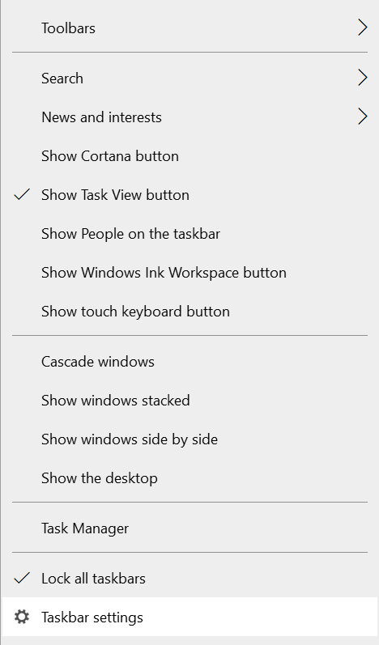Hover your mouse over the empty space in your task bar, and right click. You should get a menu like so:

Click on “Task Manager,” and your task manager should open.

Once your task manager opens, if it is the first time it is being open, it will not have all the details showing that we are looking for. It will only show the current applications you have open. To fix this, there will be a “More details” button in the bottom left-hand corner that you want to click, this will show us a more in-depth view of our system.

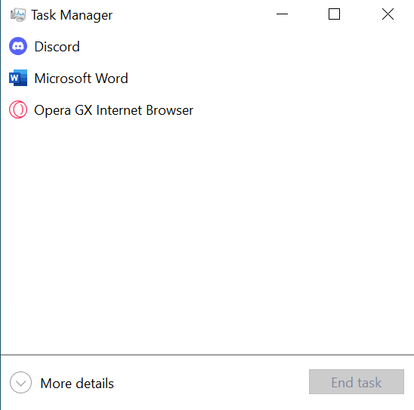

After clicking more details, there will be several tabs at the top of task manager. For this instance, we are just interested in the “Performance” tab. Click on performance.

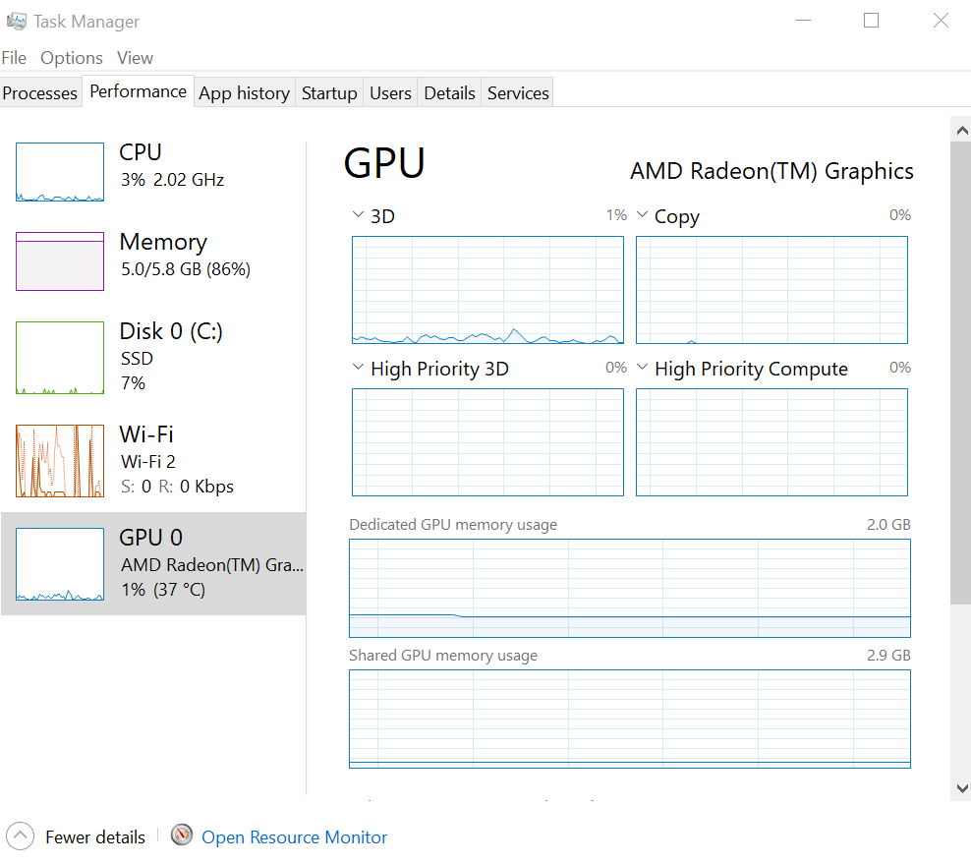

This should bring us into a view where we can see our CPU, memory, disk drives, etc. on the left side.

Compare your specifications to the ones listed right below step 1, and make sure your system can handle Windows 10! In my case, my laptop has more than enough hardware strength to handle Windows 10 as we can see in the screenshot.

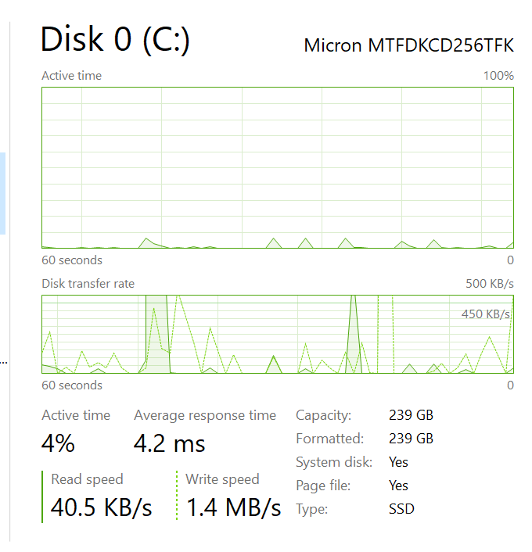To make sure your disk has enough space, click on its box on the left side. It will bring you into another view that shows its capacity.

**Step 2: Search for and download the Windows 10 media creation tool**

To download our ISO file, we first must search for the Windows 10 media creation tool in our web browser.

**Finding the media creation tool:**

Open your web browser. This can be any browser, Firefox, Chrome, Microsoft Edge, etc.

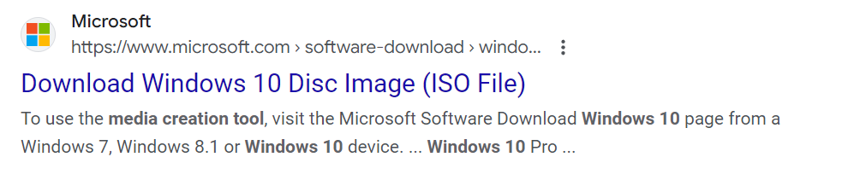In the search bar, search for Windows 10 media creation tool. Make sure the result you click on is the official Windows website. It will look like this:

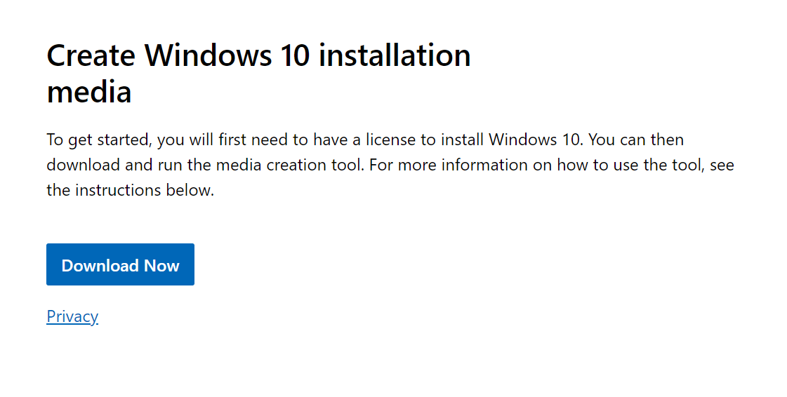Once on the website, scroll down slightly, and there will be a large blue button that says, “Download Now”. We will click this.

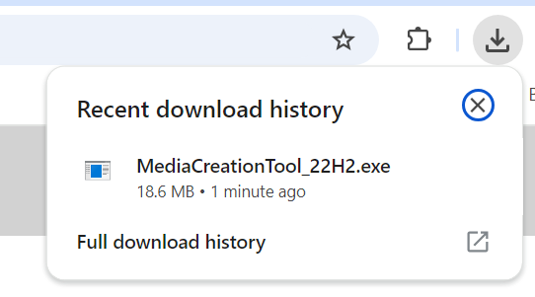The file should start downloading in the downloads section of your browser. This is in the top right corner. Click on the download’s icon, and the file should show up.

Click on the file, once you do this, a popup will ask if you would like to allow it to make changes to your computer. Click yes.

The setup will display a “Getting a few things ready.” This is normal, let it do its thing.

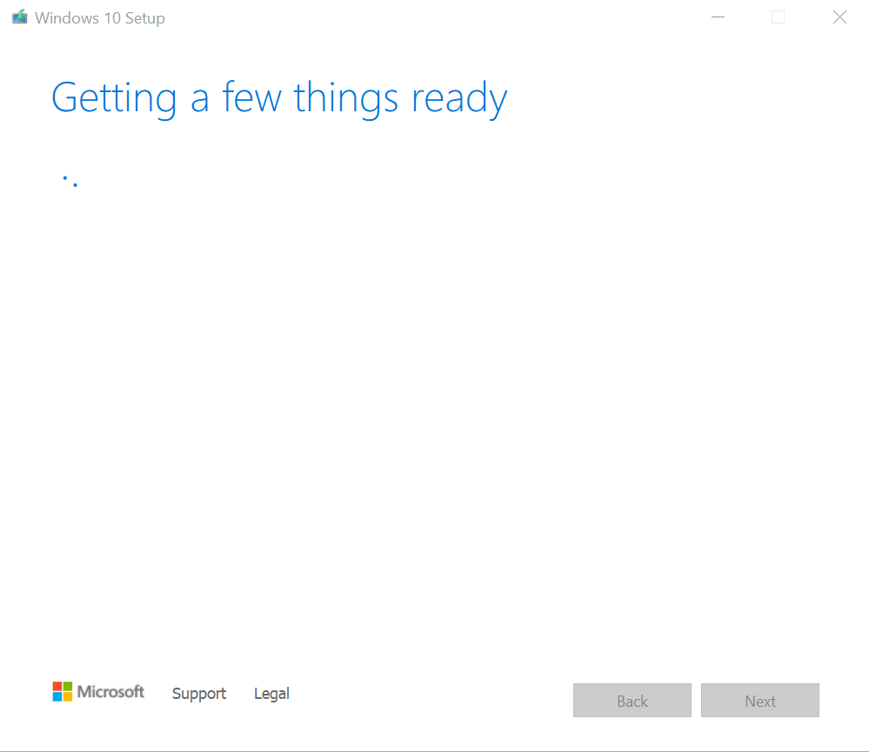

Once it is done, click accept on the applicable notices and license terms screen.

It will display the “Getting a few things ready” once more. We will again wait for it to finish.

After it finishes, another screen will popup that says, “What do you want to do?” It gives us two options, we want to choose “Create installation media (USB flash drive, DVD, or ISO file) for another PC”

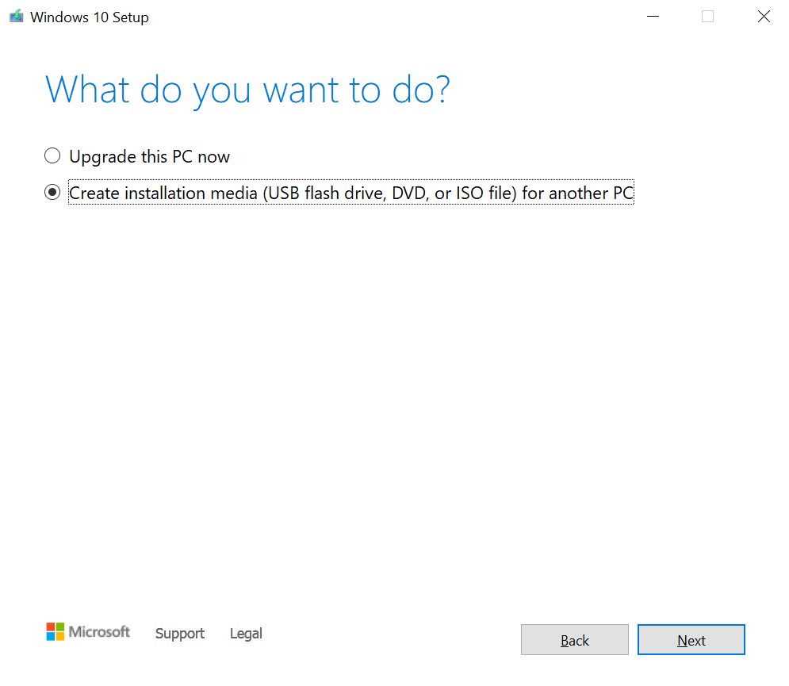

Click next

A screen saying “Select language, architecture, and edition” will be next. There is a check box stating to just use the recommended options for this PC, if you want to change any of the options, you can uncheck this box.

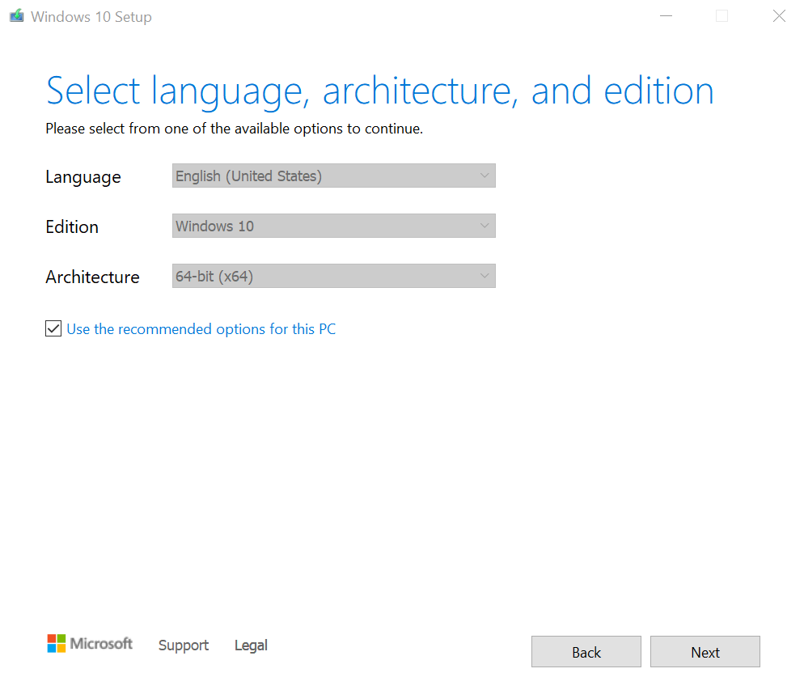Since this is a tutorial for the 64-bit version, make sure it states that beside “Architecture.” Windows usually defaults to this, and you shouldn’t have to change it.

The setup will now ask us which media we would like to use. Choose “ISO file”

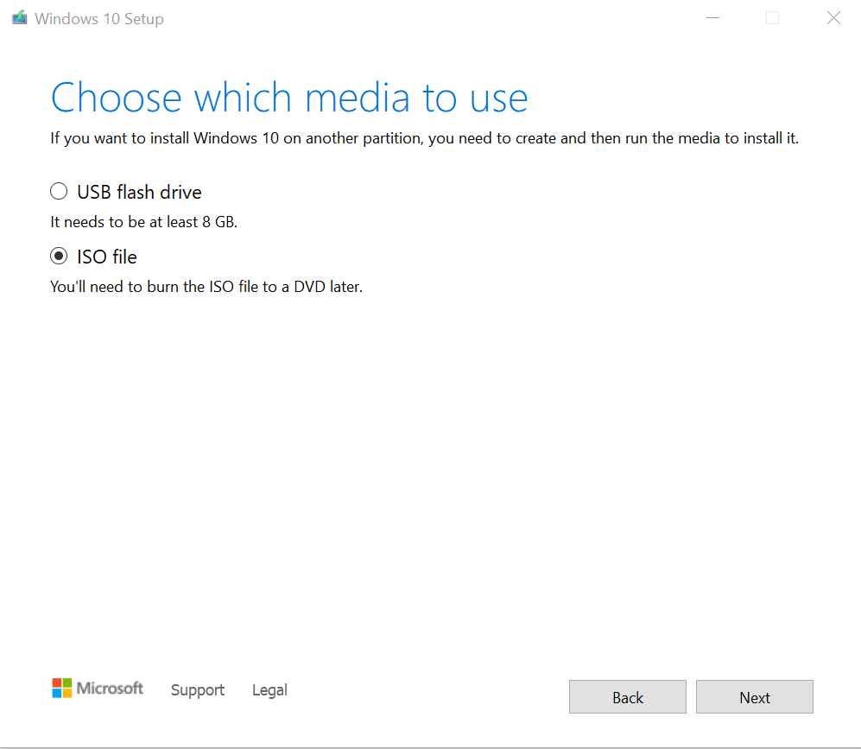

After choosing ISO file and clicking next, your file explorer will open and prompt you to save your file. Save it wherever you wish. The name defaults to “Windows”. I suggest changing the name so when you come back to it later, you know exactly what the file is. In my case, I will name it “Windows 10 64bit download”

The download process will begin, depending on your internet speed, this can take a while. Do not turn off your computer, but you are free to keep using your PC.

Once it is done downloading, it will go through another process of verifying all the files it downloaded.

That’s it! You now have a Windows 10 ISO file!

This same process can be done with a Windows 11 ISO file. You would just search for “Windows 11 media creation tool” instead.

### Downloading an openSUSE and Ubuntu ISO File

**Step 1: Search for and download openSUSE from distrowatch.com**

To find our openSUSE download, we first want to open our browser and type in “distrowatch.com” into the search bar. The website will look like this:

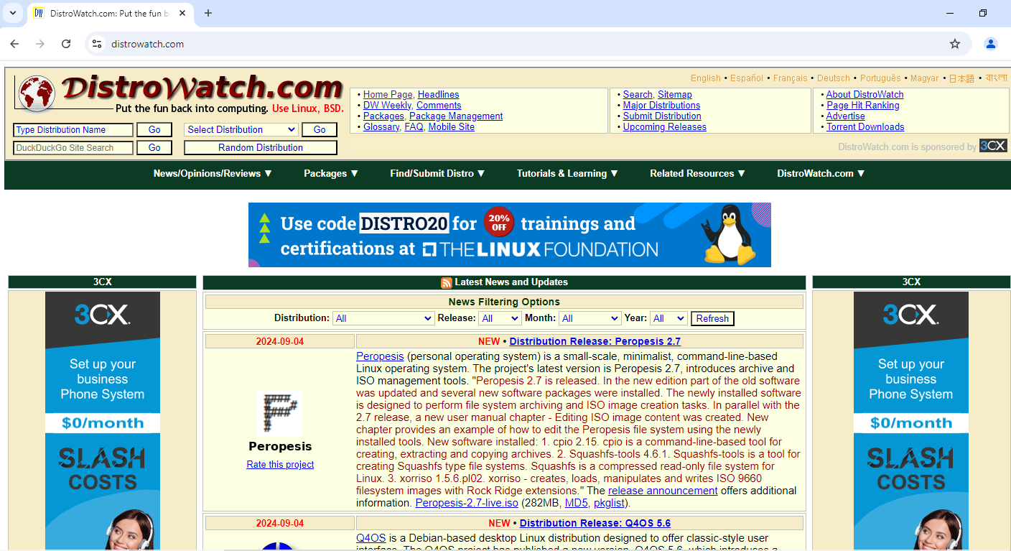

Navigate up to the links at the top and click on “Major Distributions”.

Scroll down until you find openSUSE in the list.

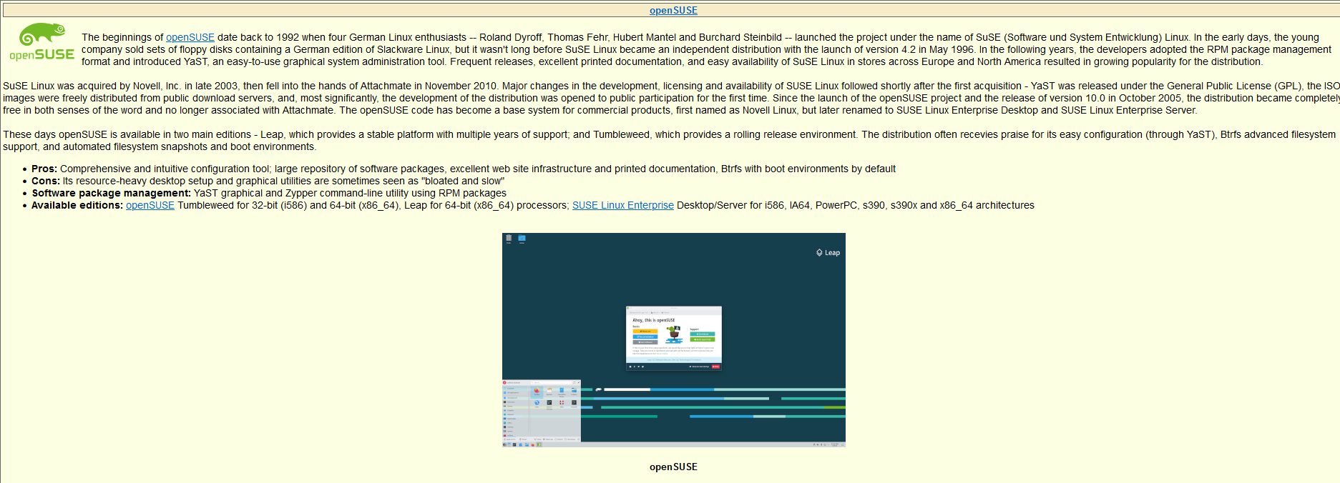

Click on the heading link “openSUSE” at the top.

This will bring us to another page that will have a link to our download.

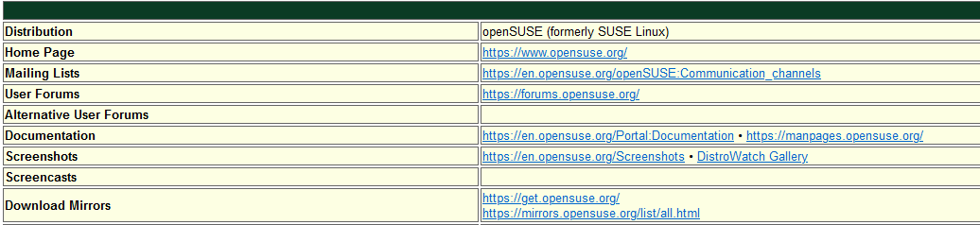

Click on the first link in Download Mirrors. This takes us to the openSUSE websites download page.

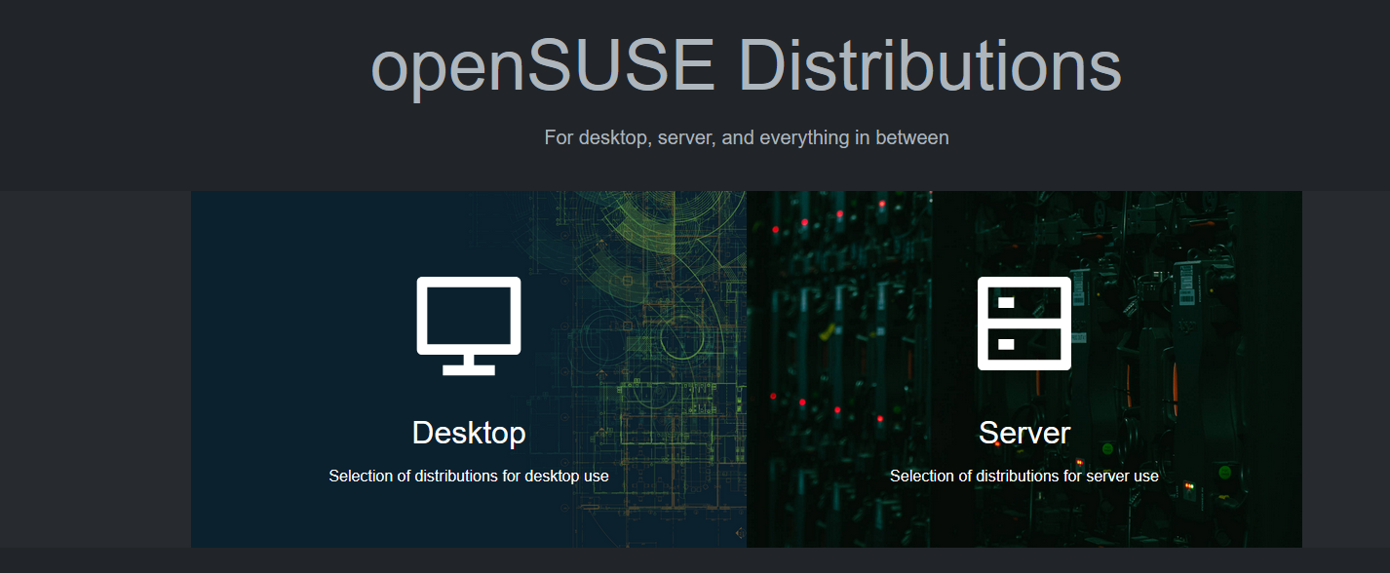

Make sure to click on “Desktop”.

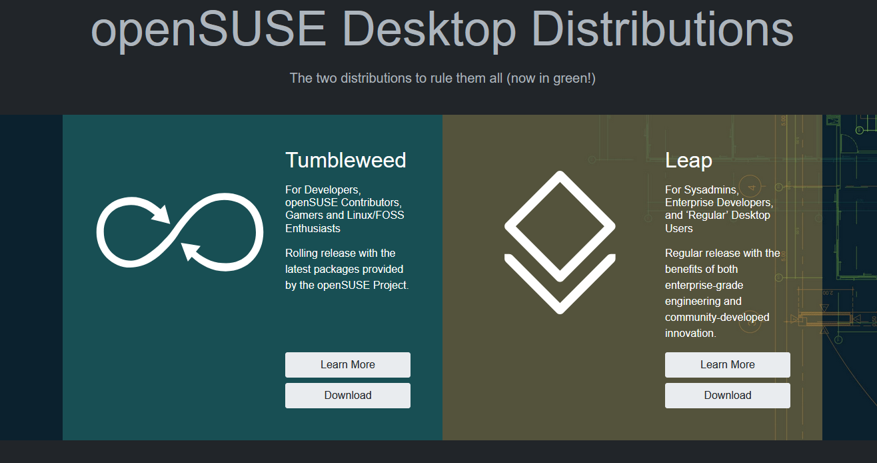

This next page will ask us if we want the Tumbleweed or Leap version, we will be using Tumbleweed. Click the download button on Tumbleweed.

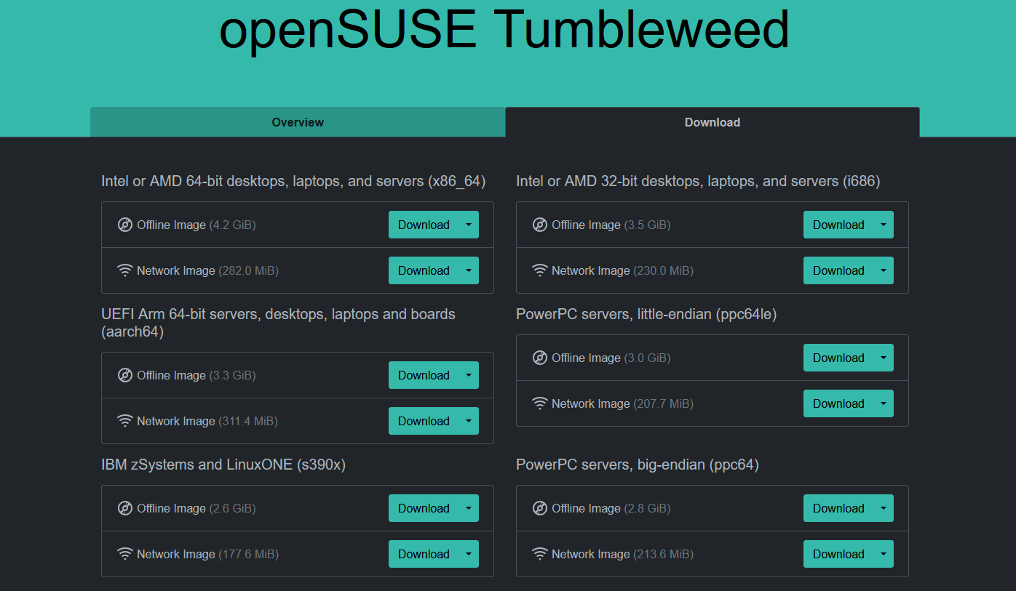

Here we have a lot of different versions. We want to make sure we’re choosing the correct download. Most likely, you will need the Intel or AMD 64-bit desktops, laptops, and servers. Click on download for the offline image

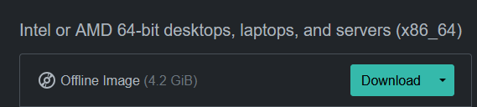

Once you click on download, it will take you to a thank you page, and the download will start in your browser.

That’s all! You now have an openSUSE ISO file!

**Step 2: Search for and download Ubuntu from distrowatch.com**

Again, we want to open our browser and type in distrowatch.com

Go to Major Distributions and scroll down until you see Ubuntu.

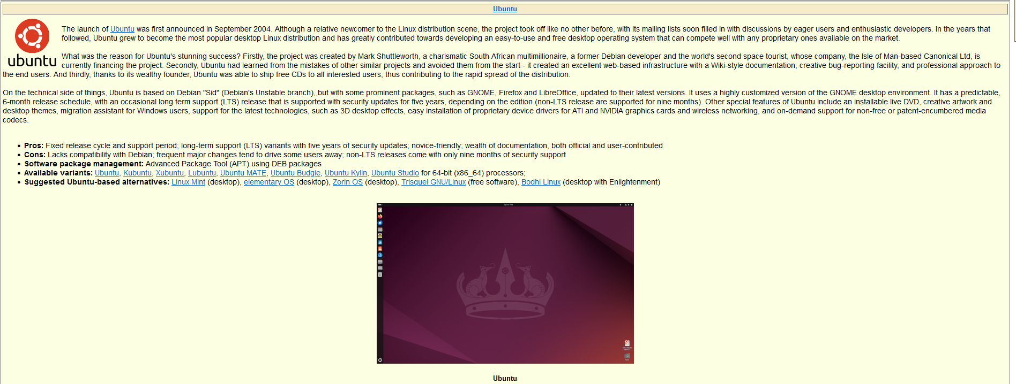

Click the Ubuntu link at the top.

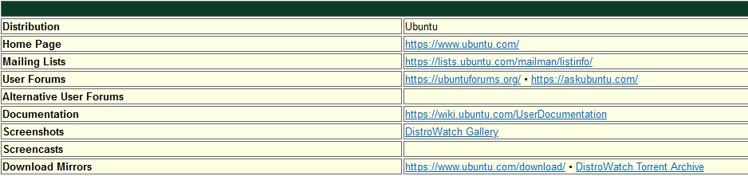

Make sure to click the first link in download mirrors. This will take us to Ubuntu’s download website.

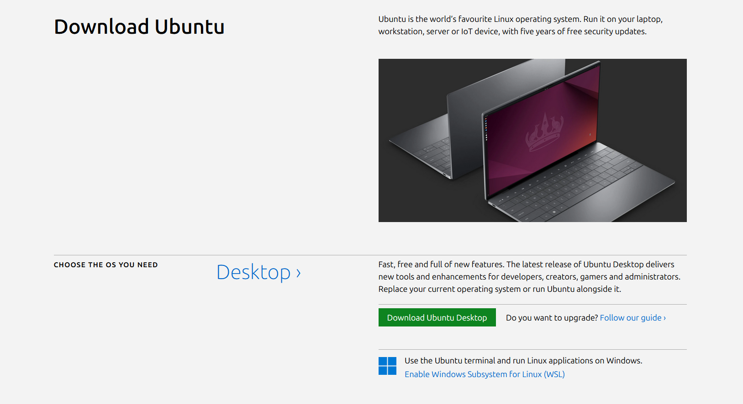

To download the desktop version of Ubuntu, we want to click on Desktop.

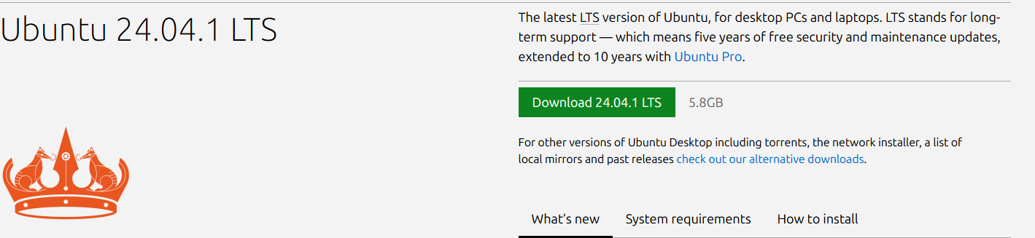

Click the green download button, it will take you to a thank you page, and the download will start in your browser.

That’s all! You now have a Ubuntu ISO file!

### Creating a New User in Windows 10

Creating a new user in Windows 10 is easy. We will use the account we make in more examples soon.

**Step 1: Find user account settings**

Navigate to the Windows button in the bottom left corner of your screen and click on settings.

Once we are here, we are met with many tiles. We want to click on Accounts.

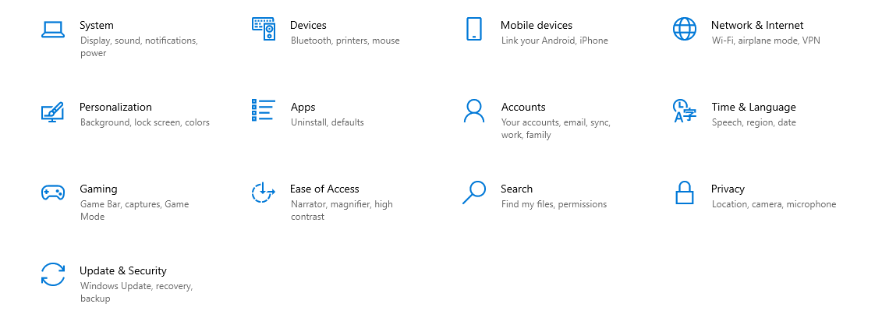

**Step 2: Create new local user**

On the left side of the screen, navigate to Family & other users.

Click on Add someone else to this PC.

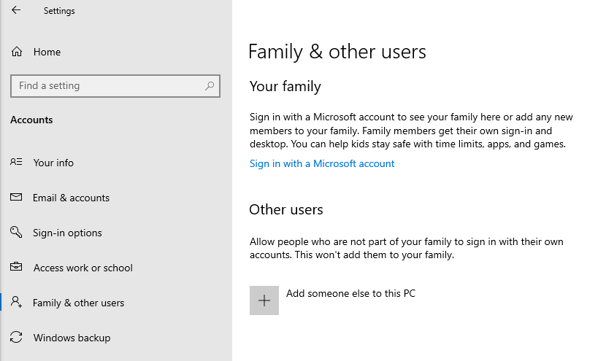

After you click on that you will get a popup asking how this person will sign in. Microsoft will prompt you to sign up with a Microsoft account. We can bypass this by clicking on “I don’t have this person’s sign in information”.

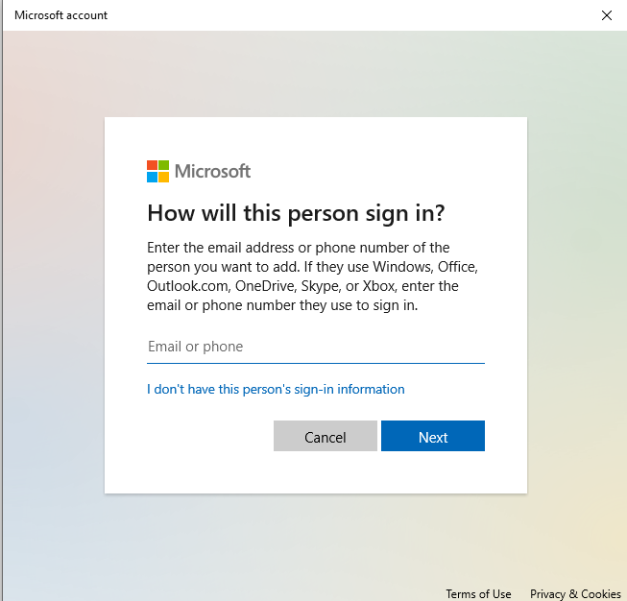

It will then prompt you to create a Microsoft account. We don’t want to use one, so we are going to click on “Add a user without a Microsoft account”.

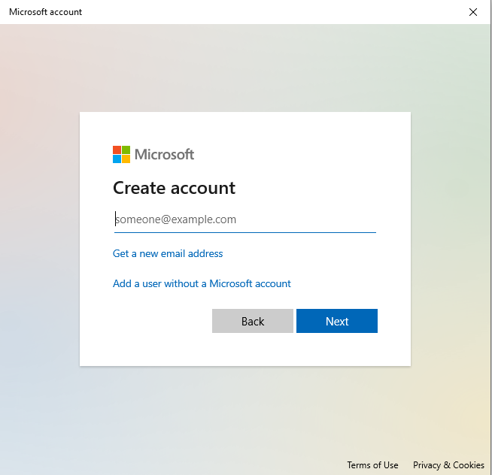

Now you can create your new user. Give it a username and password and answer the security questions. As I’ve mentioned before, this is just for learning, so we can give a generic answer to the questions, like a single capital letter.

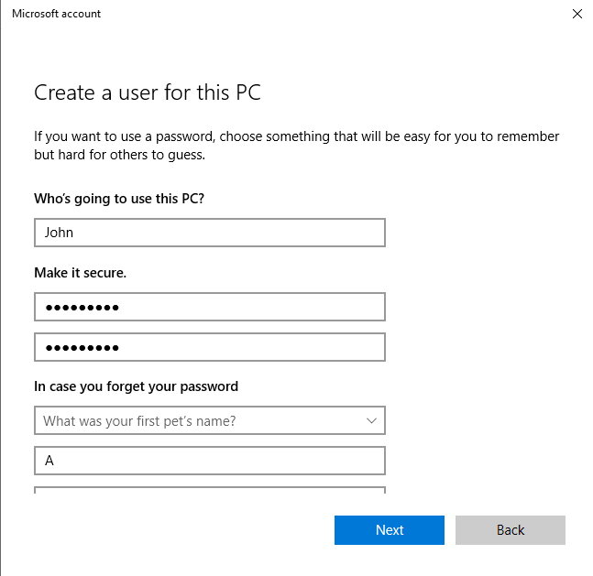

Once you’ve done this, click next, and the new account will show up.

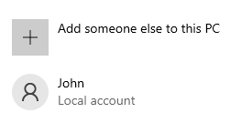

### Creating a Local Group in Windows 10 and Adding Users

Remember that local user account we created, and how I said we will be using it later? Well, we will be adding it to our local group that we are creating in this lab. If you want, you can create another couple of users to add to the group. I’ve created one more, for a total of 2.

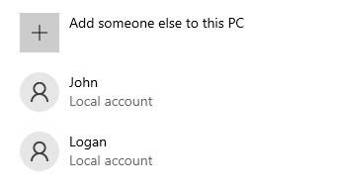

**Step 1: Create a new local group**

Navigate to your search bar in the bottom left and type in “computer management”.

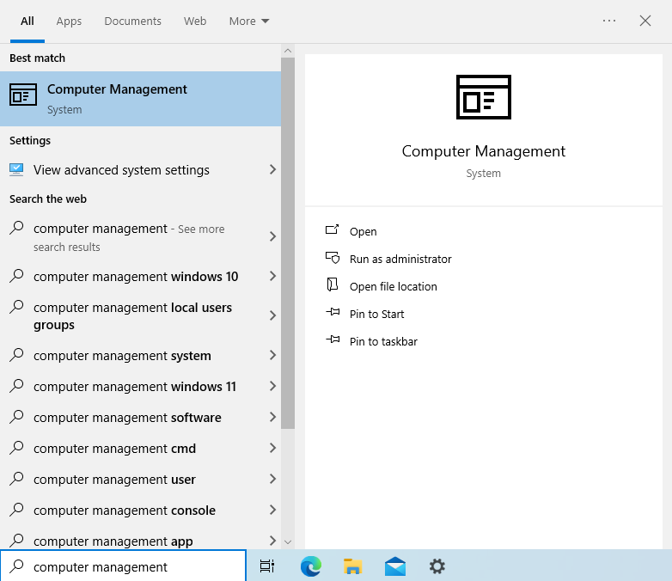

Click on the first result.

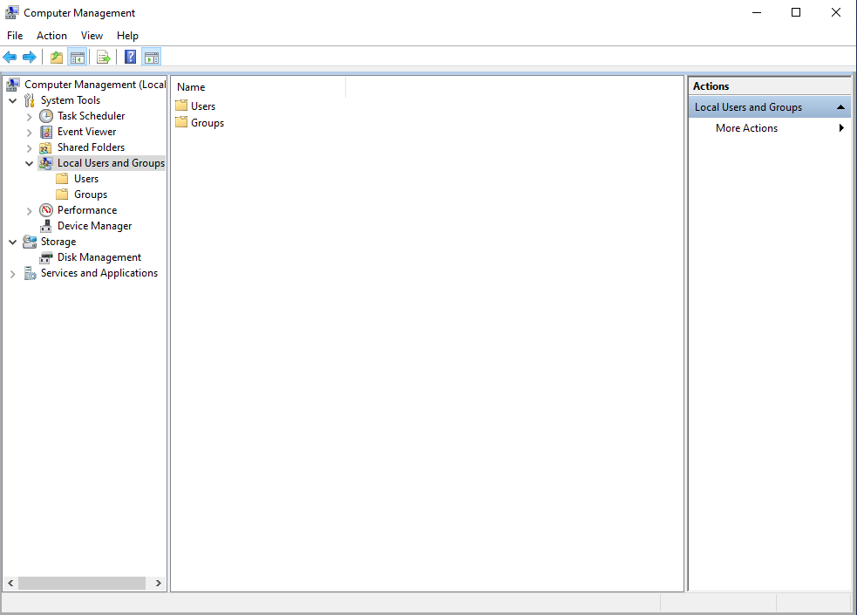

You should get a window like so. Click on the Local Users and Groups folder, then double click on Groups.

Once inside of the folder, right click on the empty space at the bottom and click on New Group.

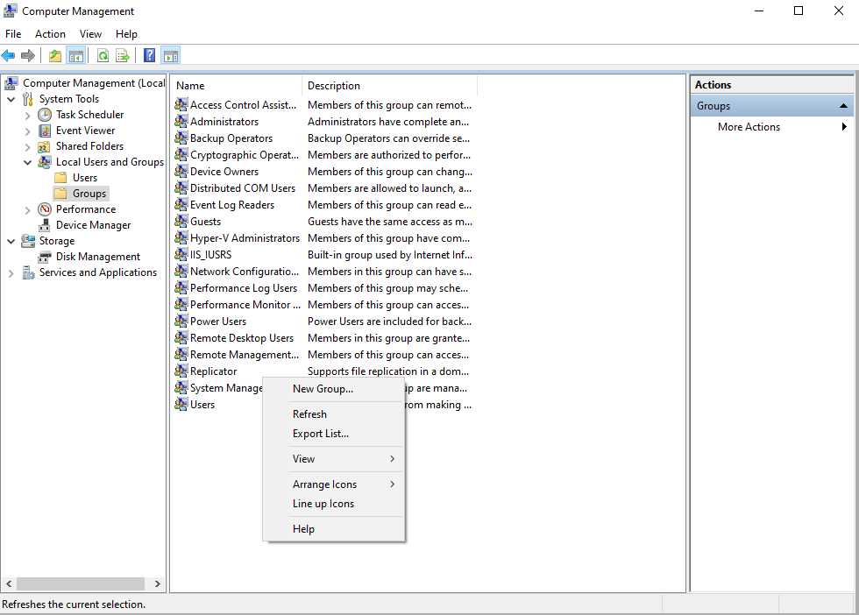

You can give your group a name and description.

**Step 2: Add users to the group**

To add the local accounts you created to the group, click Add on the bottom left.

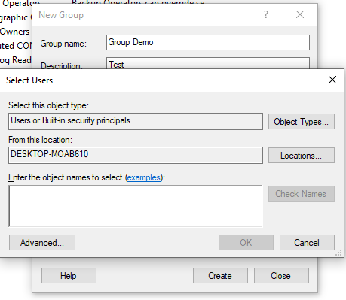

To easily add the local accounts, type the name of the accounts separated by a semi colon like so:

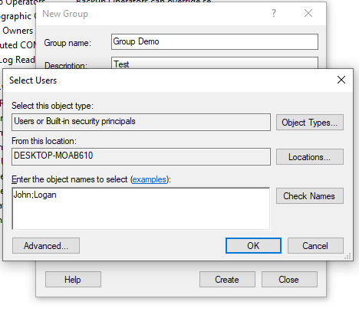

Click on Check Names. If it finds the names, they should be auto completed.

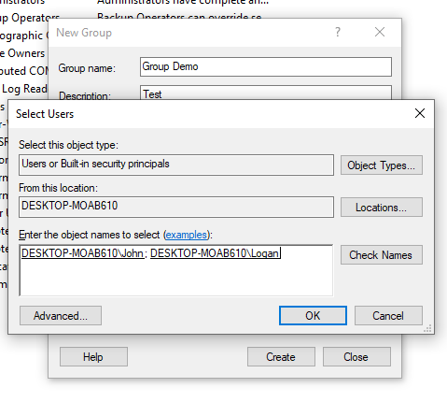

Click OK.

You should now see the users in the group.

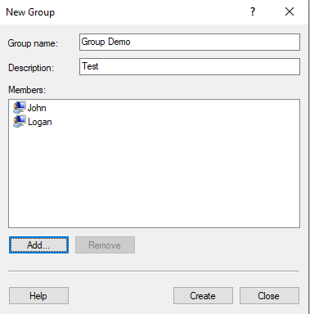

Click create. The new group screen will go blank again, do not worry about this. Click close and your new group will show up at the bottom.

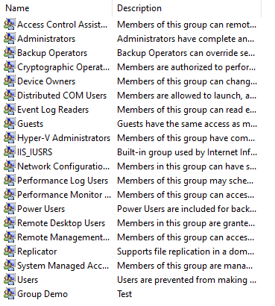

PS: Make sure you add your own account to the group too. One more time, click on Add.

Type in the name of your local account and click check names. Mine is student.

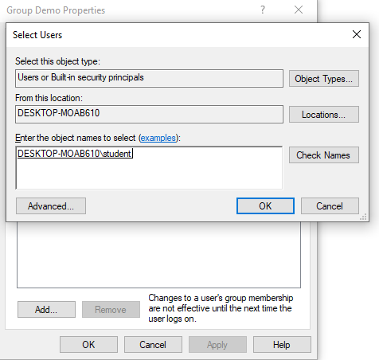

Click OK and you should now be in the group.

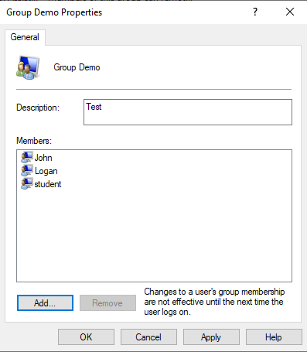

Click apply, then OK.

You now have a local group! We will, again, soon be using these accounts we created.

### Creating a Network Share and Using NTFS Permissions

A network share is a resource that is made available to other computers on the network. This can be helpful for file sharing across user accounts and other devices on your network. Don’t worry, this will only be available to any device connected to your network, not outside users. We will make sure of this with a security setting.

As for NTFS permissions, they are a set of rules that decide if a user has full control over a file or not. I will showcase this.

**Step 1: Create a file you want to share**

For this example, we will be creating a folder on our desktop. Right click on your desktop, click new, then folder. Name your folder whatever you like.

**Step 2: Add users**

Rick click on the folder you created, properties, then navigate to the security tab.

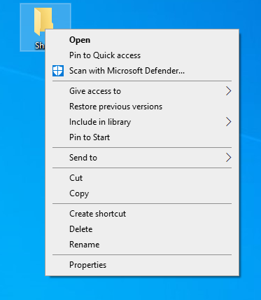

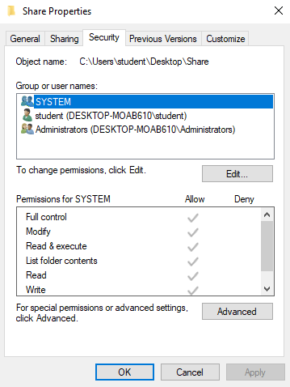

This tab shows who has access to the file and what permissions they have. To add new users, click on add, and it is the same premise as adding users to the local group. Type in their names separated by semi colons and click check names.

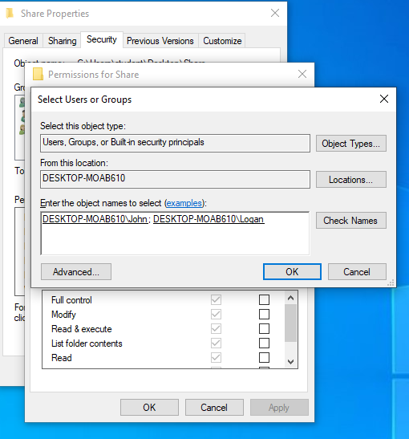

Click OK, apply, and OK again. You should now see the users in the list.

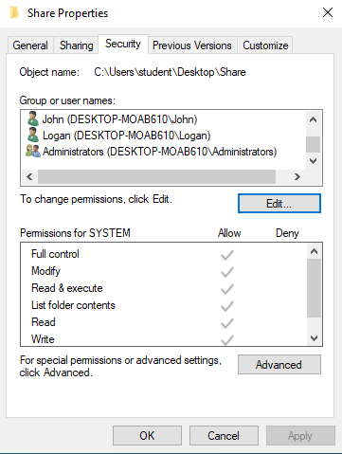

**Step 3: Edit NTFS permissions**

To edit the permissions of the users we just added, we want to go to that same security tab in the properties of our shared folder.

Once we get there, we can click on a user in the list to edit their permissions. By default, they get limited permissions. I will be giving one account full control, and one account read only permissions.

Click on the user you want to edit permissions of and click edit.

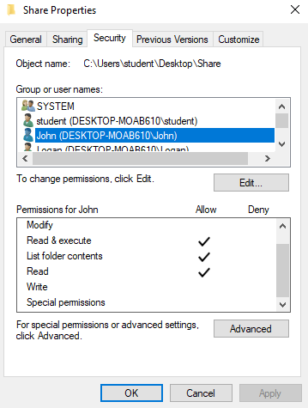

This will bring up a permissions window. Click on the user again. For John I will be giving full control. Click the check box.

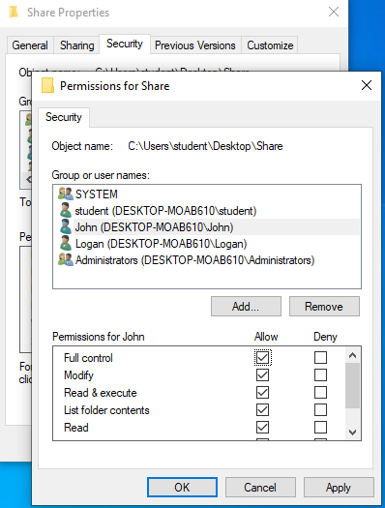

Apply, and then OK.

Same thing for our other account. Navigate to the permissions window.

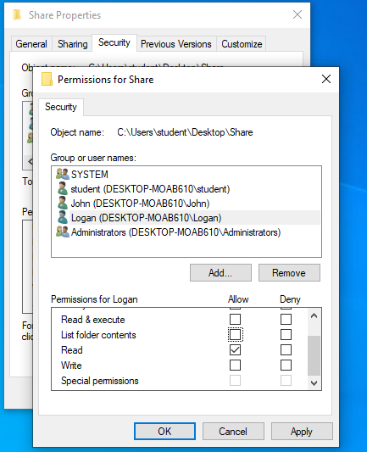

For Logan, I am giving read only.

**Step 4: Create a network share**

We have added our users and edited their permissions. We now want to create a network share so they can access it from their File Explorer.

Navigate to the properties of our shared folder, and click on the sharing tab.

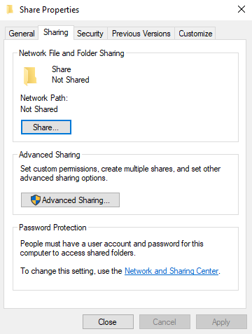

Click share.

All your accounts that have access to the folder should appear here.

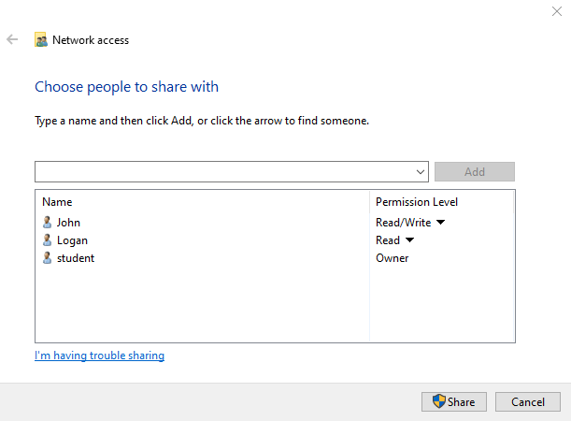

Click share.

This will open an important window.

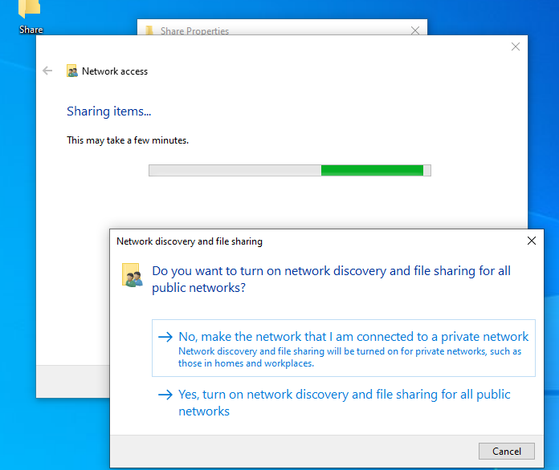

Please make sure to click no for this. This is the security setting I referenced earlier. You do not want this on the public network.

You should now get a file path. Make sure to copy this so you can test it on a different user account.

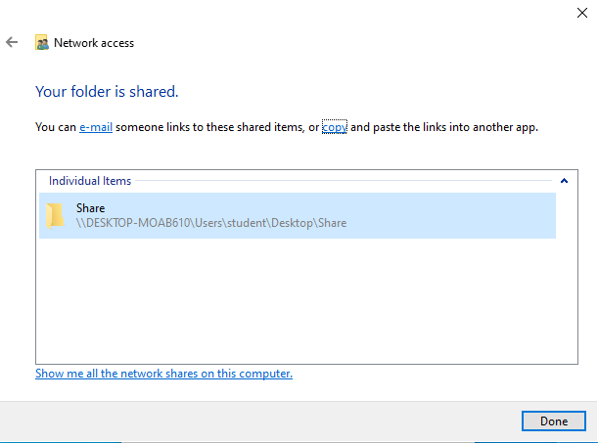

Note, if you click the “copy” button, this can mess up your backslashes \\ and change them into forward slashes //.

Mine did like so: Share (//DESKTOP-MOAB610/Users/student/Desktop/Share)

If you try to navigate to the folder using this, it will not work. Make sure you change the forward slashes into back slashes.

If you ever need to get the network path again it is always available in the sharing tab of the properties of the folder.

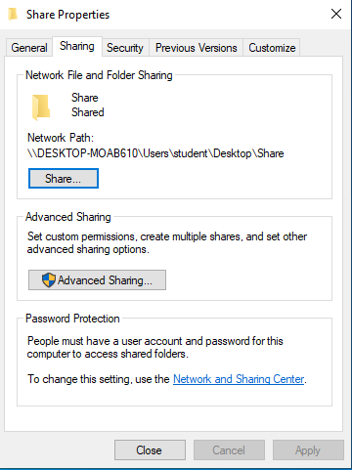

**Step 5: Test your network share**

We now want to make sure our network shared folder works! Sign into one of the accounts you created.

If this is your first time signing into the account, Windows will do some setup. This is normal.

Open your file explorer and click on network. Your shared path should show up here.

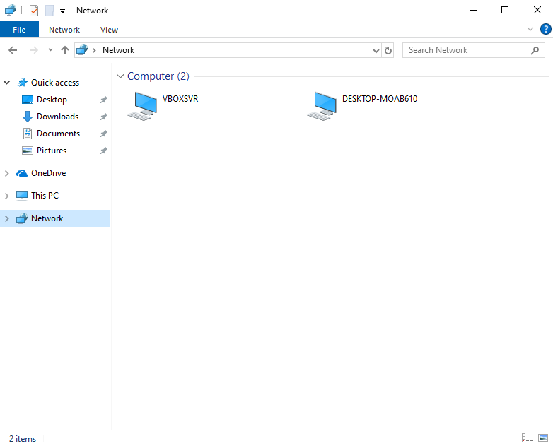

Double click on it, users, the name of your account, desktop, and then we can see the shared folder we created here.

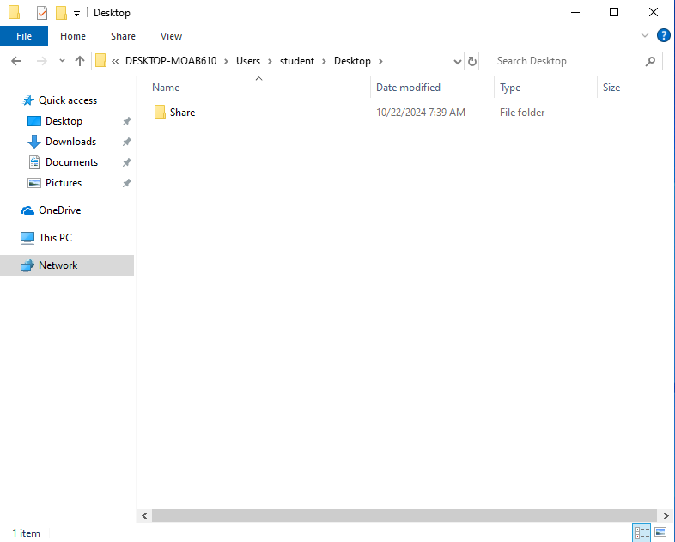

You now have a working network share!

## Virtual Machines

### Creating Windows 10 and 11 Virtual Machines

**Step 1: Download Oracle VirtualBox, Microsoft Visual C++ Redistributable** **Package, and Oracle VirtualBox Extension Pack**

Before we get started, make sure you have a Windows 10 and 11 ISO file. Refer to the operating systems section to learn how to acquire one.

Oracle VirtualBox is a great tool for making many kinds of virtual machines. For this section, we will be going through how to install Oracle VirtualBox and make Windows 10 and 11 Virtual machines!

**Downloading Oracle VirtualBox:**

In your browser, search for “Oracle VM VirtualBox”, It should be the first result, or type in virtualbox.org to go directly to the website.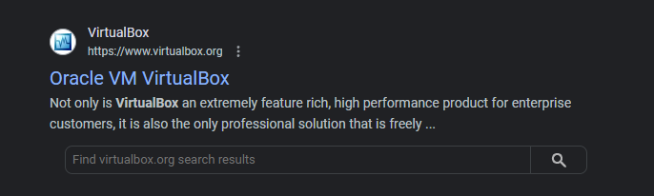

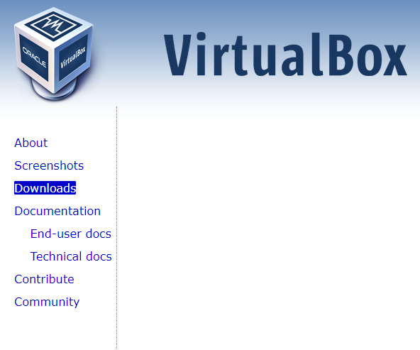Once we’re on the main page we will see a series of navigation buttons to the left of the page, we want to click on downloads.

This takes us to the downloads page; we want to make sure we’re choosing the correct download for our operating system. I am using Windows, so I will be choosing “Windows hosts.” If you’re on macOS or Linux, there are downloads for those operating systems as well. 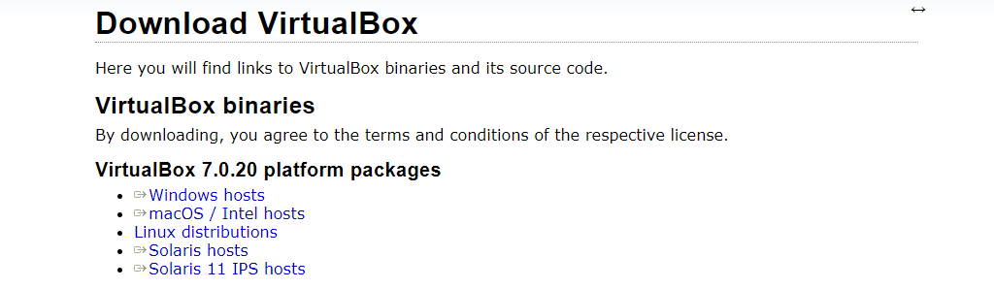

Clicking on Windows hosts will start the download in the downloads section of your browser.

When VirtualBox finishes downloading, we want to make sure we download Microsoft Visual C++ Redistributable Package. Oracle VirtualBox needs this to run, and it is likely you do not have this program. If you do, you can skip this step.

**Downloading Microsoft Visual C++ Redistributable Package:**

In your browser, search for Microsoft C++ Visual Redistributable Package. Click the first result. 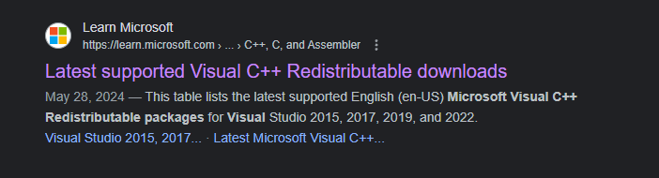

On the page, scroll down to “Latest Microsoft Visual C++ Redistributable Version.” 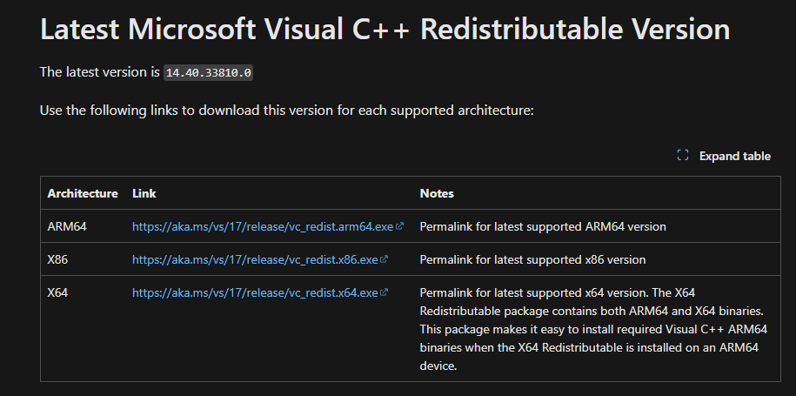

We want to make sure we click the link beside X64. This will start the download in your browser. After it finishes, launch the installer from your file explorer. You can find where it is in your file explorer by clicking the small file icon next to the download in your browser.

A window will pop up asking you to agree to license terms. 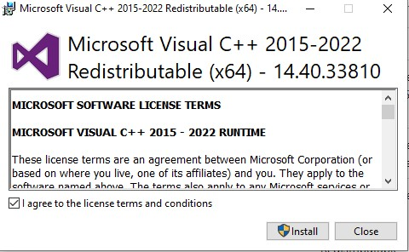

Click the check box, then click install.

Another window will pop up asking you to allow this program to make changes to your device, click yes.

The installation will begin. Once it finishes, it will require a system restart.

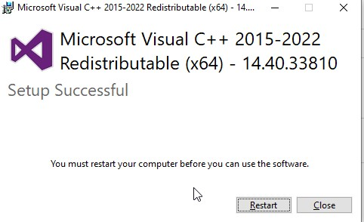

Make sure your computer restarts before going to the next step!

**Downloading Oracle VirtualBox Part 2:**

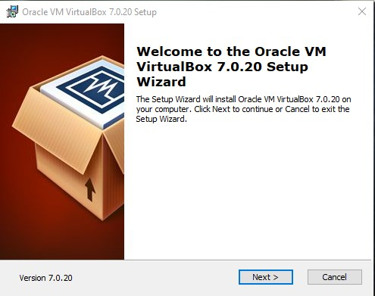After your computer restarts, run the VirtualBox installer from your file explorer. A popup will ask you to allow it to make changes to your device, click yes. After, the setup wizard will come up.

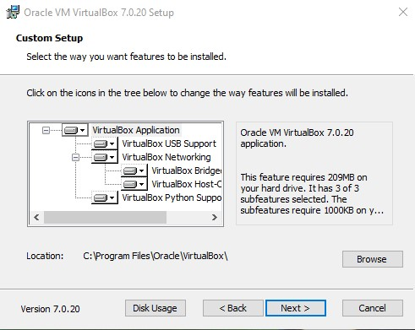After clicking next a series of a couple pages will ask us to select the way we want features to be installed. All these defaults are fine, and we can go to the next page.

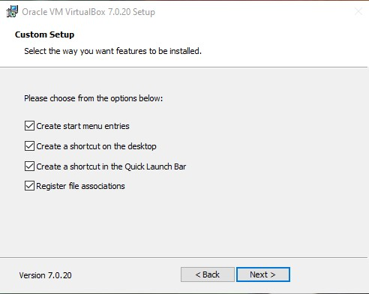

This brings us to a warning from VirtualBox stating that it will reset your network connection. Make sure you are not downloading or doing anything else important during this time.

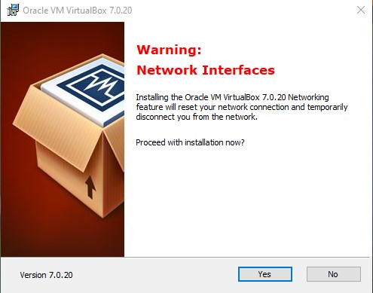

Click yes, and the installation will begin. After it is done, it will come to a finished screen and ask if you would like to launch VirtualBox. I would suggest unchecking this box, because we have one more thing to download.

**Downloading VirtualBox Extension Pack:**

The VirtualBox extension pack is an add-on that enhances its capabilities. We want to have this for future endeavors!

The extension pack can be found in the downloads section on the virtualbox.org website.

On the same page we were on earlier, scroll down slightly to “VirtualBox 7.0.20 Oracle VirtualBox Extension Pack” and click on “All supported platforms”.

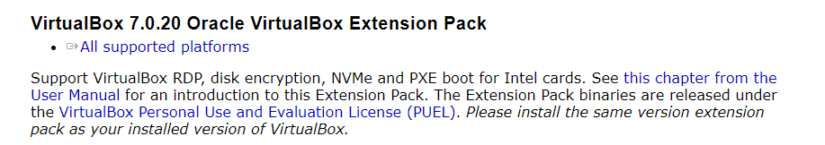

Once this downloads, all we must do is run the installer. After running the installer, VirtualBox manager will come up and ask us if we want to install the extension pack, click install.

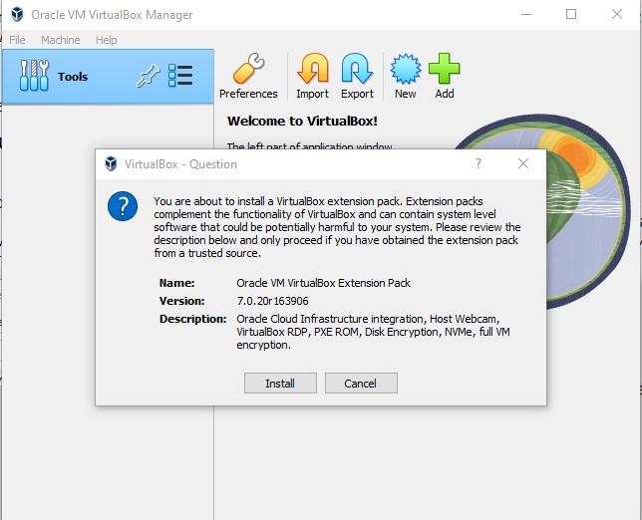

One more thing we want to do is make sure we choose a drive for all our machines to go to. Virtual Machines can take up a lot of space, so make sure you choose a drive that has plenty of space.

For this, we click on File, Preferences, and in the General tab there will be a “Default Machine Folder” option, make sure you choose the drive you wish to use.

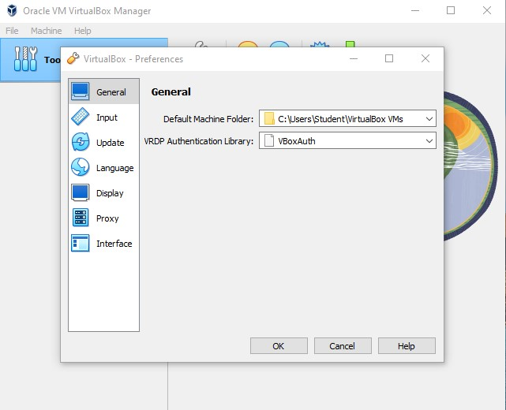

That’s it! We can now make our first virtual machine.

**Step 2: Making Windows 10 and 11 Virtual Machines**

**Making a Windows 10 Virtual Machine:**

To make our machine, we want to navigate up to where it says “machine” in the top left and click on it. A menu will come up asking if we want to add or make a new machine, click new. We can also simply click the “New” button to the right.

After, a window will come up asking us to name our operating system, choose a folder for it to go in, and the ISO image we want to use.

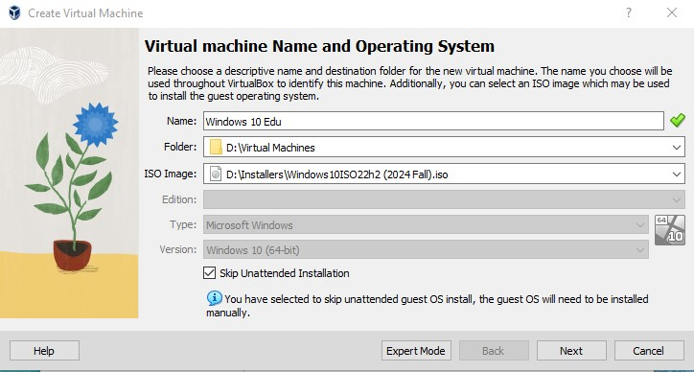

I recommend naming it the specific Windows version you’re going to choose when setting up Windows inside of the machine, in my case, I will be using Windows 10 Education, so I named it “Windows 10 Edu.”

Choose the folder the machine is going to go in, and then your Windows 10 ISO image.

You will see a checkbox beside something that says, “Skip Unattended Installation”. If you want, you can leave the box unchecked, in this example, I will be skipping the unattended installation.

The next screen will ask you to set the resources the VM will share with the host machine. It’s always a good idea to give the machine just enough, but not too much. There are color indicators showing what is okay to give it, and what may be too much. This all depends on your hardware, for me, I will be giving it 8192 MB, or 8gb of RAM, and 4 CPU’s. You can slide the slider across the bar, but the easiest way is just typing in the amount you want. Remember the operating system itself takes resources, and you should take this into account as well.

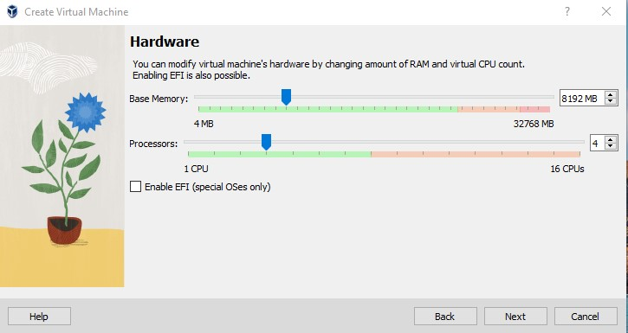

Make sure to leave Enable EFI unchecked in this instance.

Another screen will ask how much virtual hard disk space we want to give the machine. I recommend, depending on your space, to give it 100 more GB than what it presets for you. You can always go back and change this later if it is too much. Make sure to leave the “Pre-allocate space” box unchecked. Virtual Machines only take up the space that they need. They will not take the full, for example, 150GB that you set the virtual disk space to. They can only take up to that amount of space. Otherwise, they will not take this space if it is not needed for downloads you may put on it later.

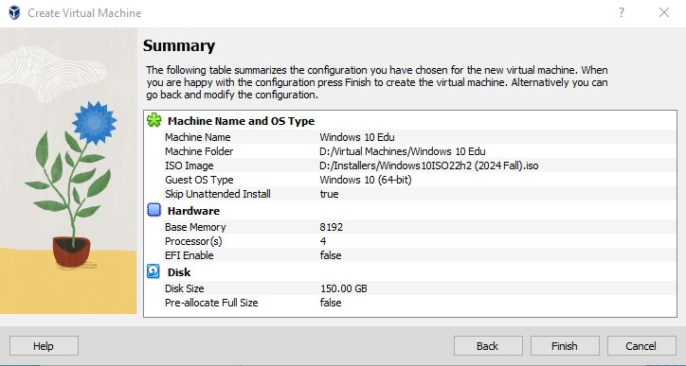You’re now in a summary page, click finish.

You should now see your Windows 10 VM on the left side of the VirtualBox manager.

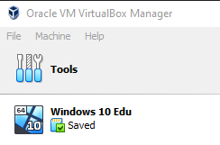

We will double click it to launch. Give it a minute to boot up.

Once the VM starts, we should come to a page where we will start setting up Windows 10!

**Setting up a fresh Windows 10 Install Inside of a VM:**

This first page is simple, and just wants us to choose our region and language.

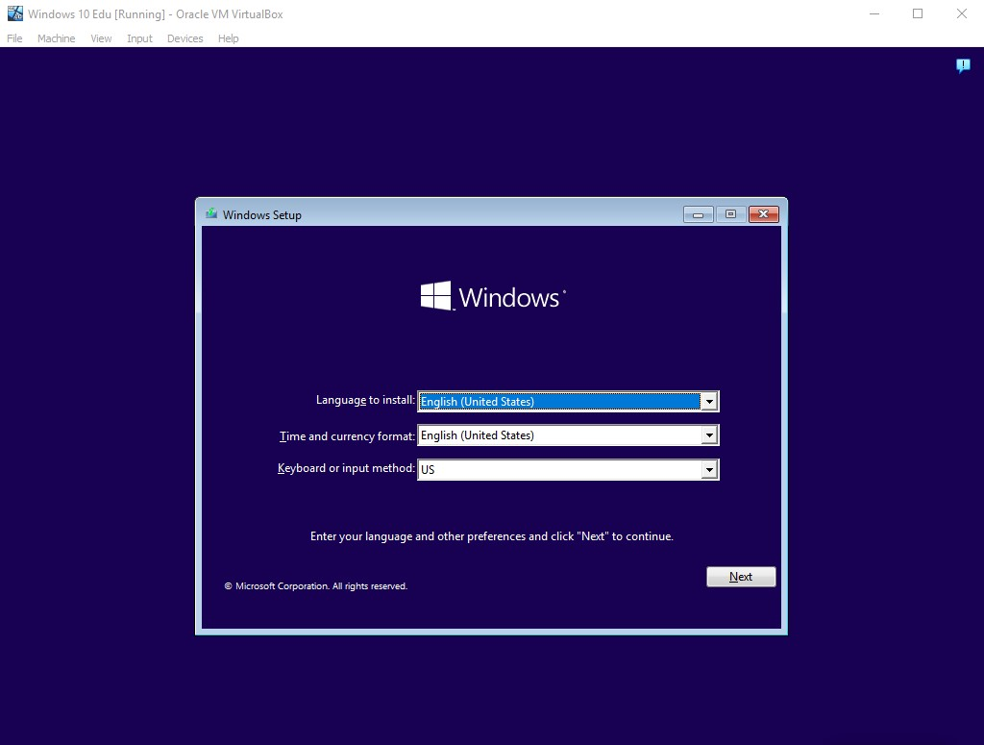

After making your choices, click next, and then install now.

We now come to a product key page, where Windows is asking us to put in a product key. The product key normally will determine what type of Windows 10 we are installing, in this case, we do not have a product key, so at the bottom choose “I don’t have a product key.”

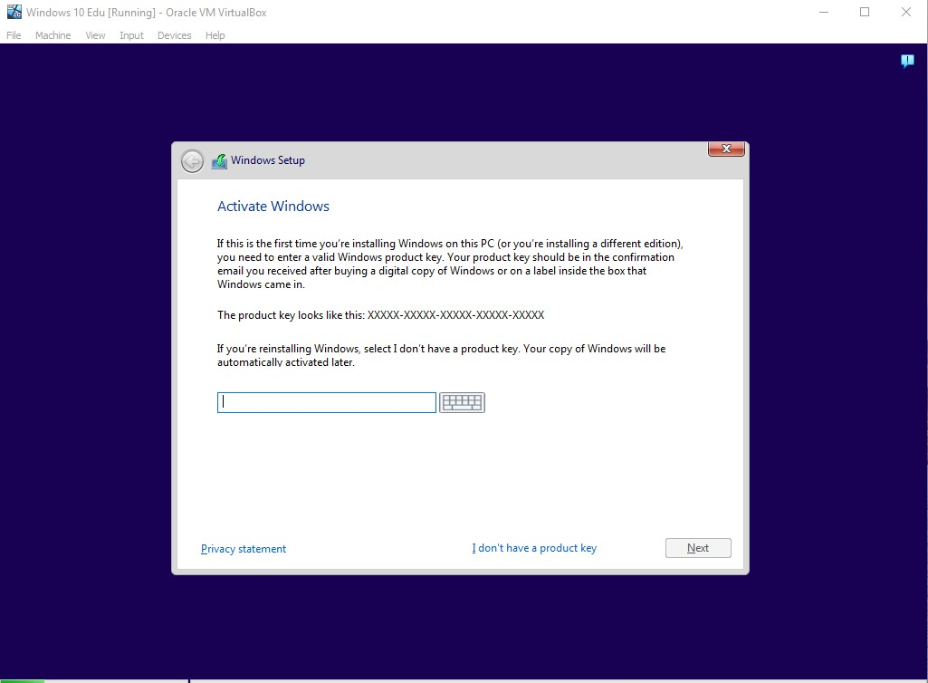

It will then ask you what type of Windows edition you would like to install. As previously mentioned, I will be installing Windows 10 Education, but you can choose whatever edition you wish here.

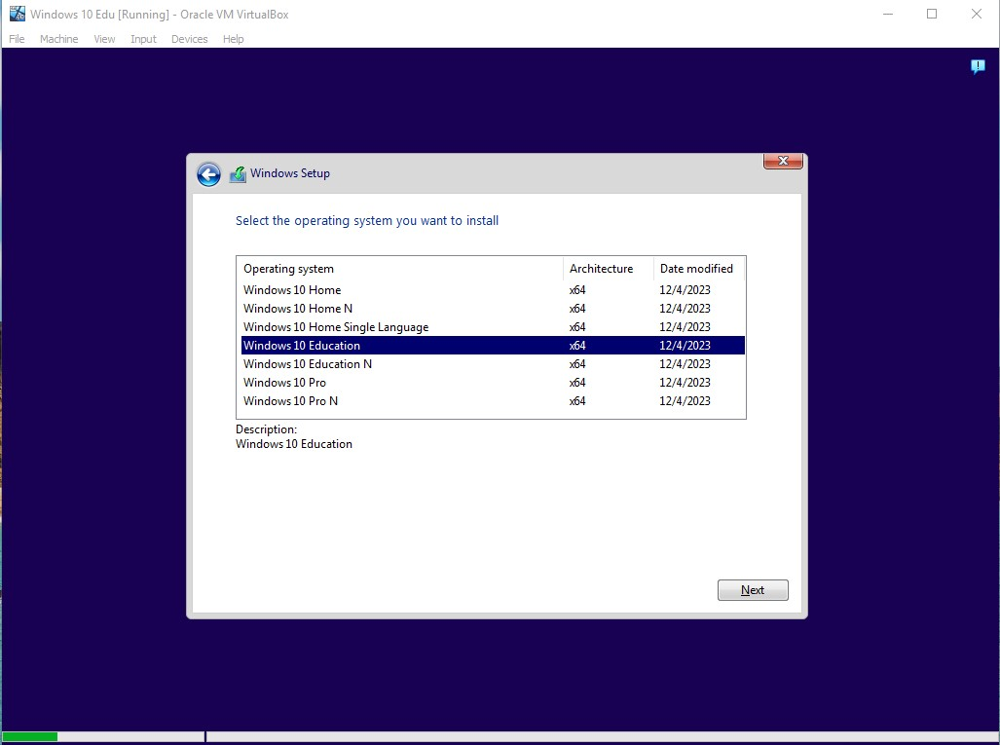

It will ask you to accept license terms, after this, click next.

We will then be prompted to choose what type of installation we want to do. Upgrade is for if you already have an OS on a device and want to upgrade. For this, we will be choosing custom install.

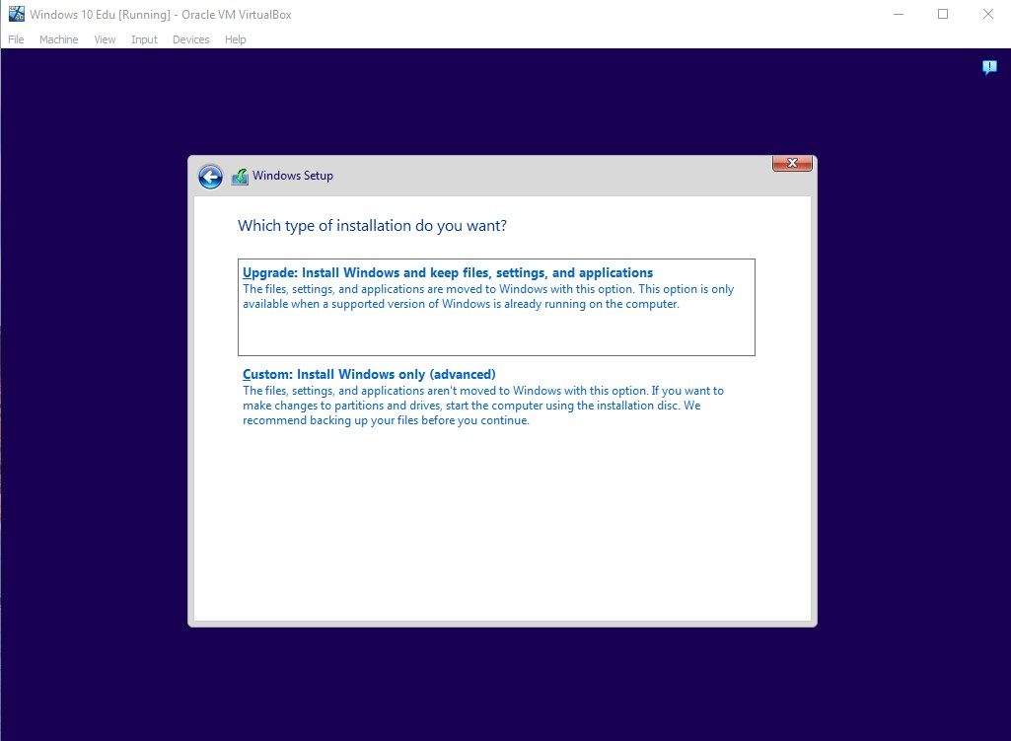

We then need to choose which drive Windows will go on. As you can see, we have the 150GB virtual disk space we gave to the VM earlier. Click the drive and click next.

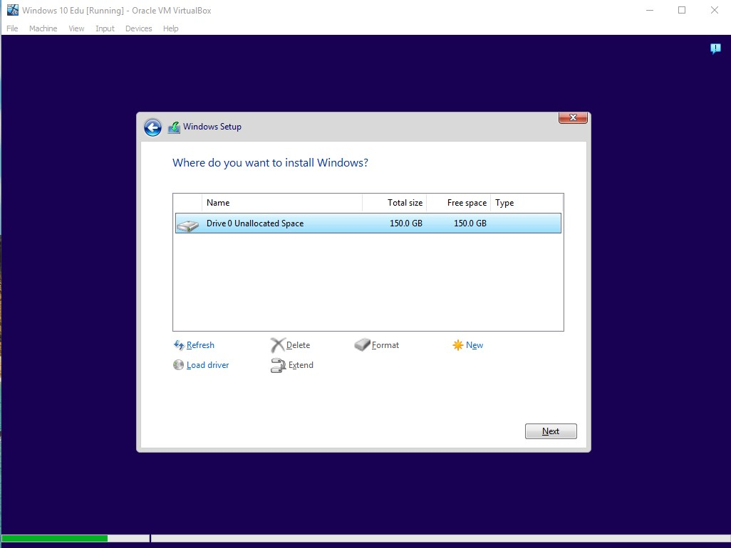

After clicking next, the download process will begin. Windows tends to take a while, so let it do its thing.

When the “Press a key when CD…” prompt comes up, make sure you do not press a key.

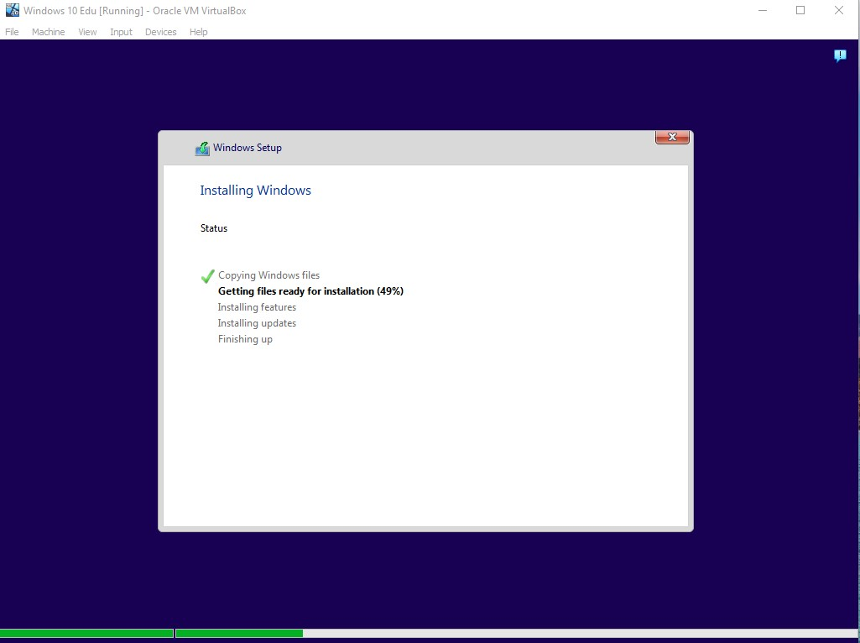

After this process is finished, it will require a restart. Go ahead and restart. This can cause a potential issue with your VM where it does not fully restart. If this is the case, go up to machine in the top left, power off, and re-open the machine. That should fix the issue.

Windows will again load for a while and may restart a couple more times during this process.

Once it is done, it will prompt us to select our region again, keyboard layout, and any secondary keyboard layouts. Choose your respective options and continue with the installation process.

Windows will load once more.

We now come to a screen that asks us to sign in with Microsoft. We are going to bypass this, so we aren’t adding our Microsoft account to the Virtual Machine. Instead of typing in an email, we want to click “Domain join instead” in the bottom left corner.

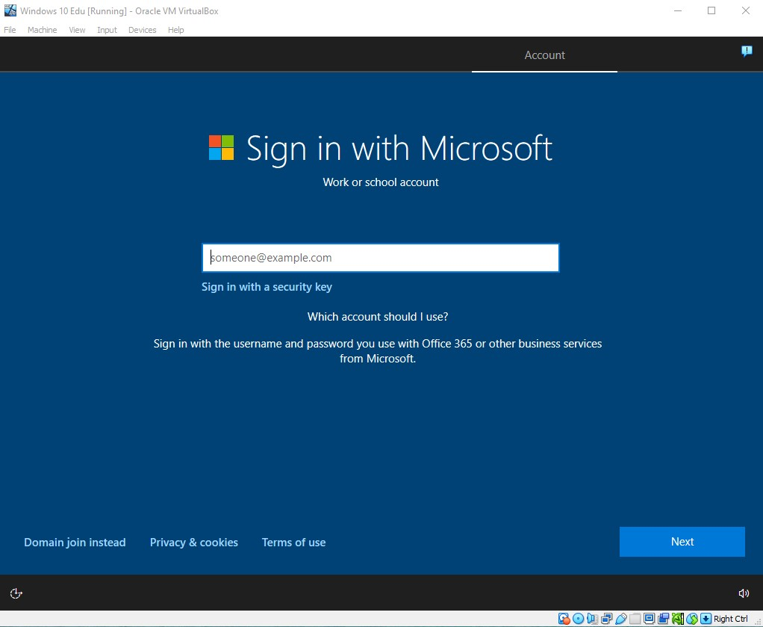

Choose a username and password you would like to use.

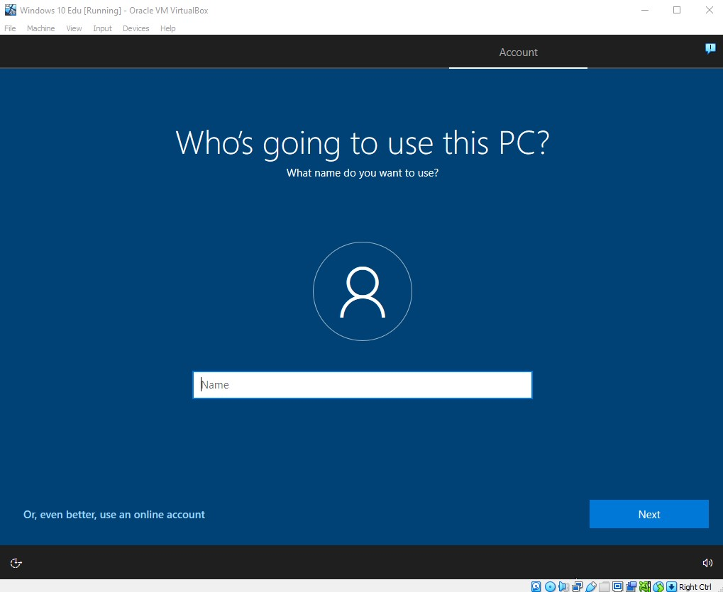

We will then be asked to set up a series of 3 security questions. I recommend choosing random ones and making the answer something very simple, like a single capital letter. This is a learning environment, and we do not want any personal information on it.

We have now come to the privacy settings screen. I highly recommend sliding of these to no.

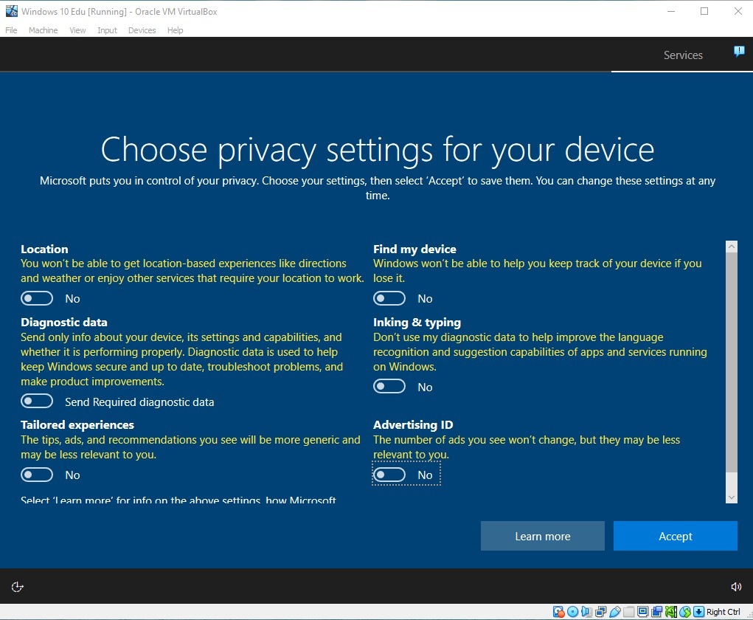

It will then ask if you would like to set up Cortana. I personally recommend selecting not now.

Once again, Windows will load some more.

After that is completed, you should be in Windows 10! We want to do one more thing.

Navigate up to devices, then insert guest CD image.

We then want to navigate to the installer in our file explorer and run it.

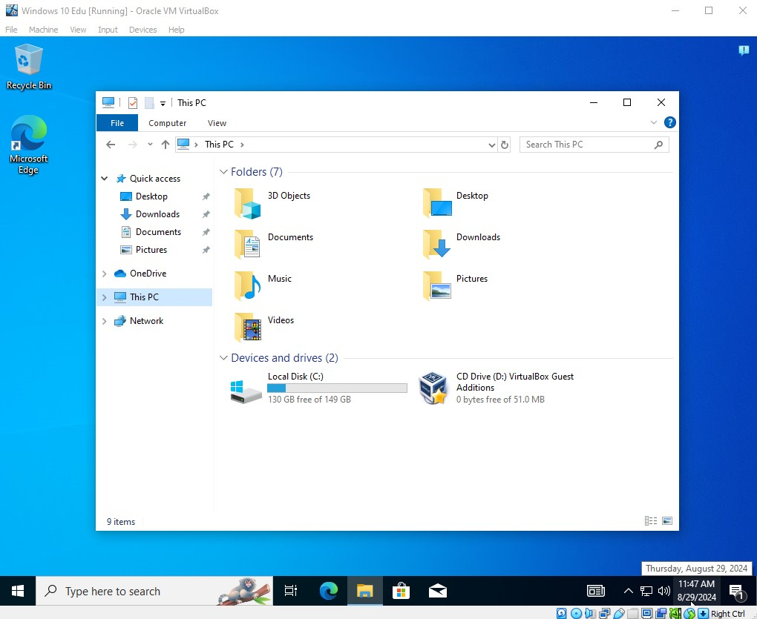

Once you run it, allow changes, and the installer should pop up.

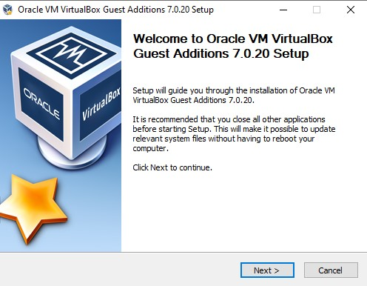

Choose your location and components, and then install. The virtual machine’s screen will flicker a couple times, this is normal.

You may also need to change your time zone, if you want.

That’s all. Your Windows 10 virtual machine is now set up and ready to go!

**Making a Windows 11 Virtual Machine:**

**A few important notes:**

* *When prompted about the “Enable EFI” checkbox, make sure to* ***check*** *it this time around.*
* *When the “Press a key when CD…” prompt comes up, make sure to press a key this time.*
* *Make sure all privacy settings are set to no.*
* *Give Windows 11 a bit more memory and storage space this time around, as it requires more than Windows 10.*
* *Make sure to skip unattended, if it gives you the option to.*

Making a Windows 11 virtual machine is virtually the same with a few differences.

If you need help creating a new virtual machine, refer to page 22; “Making a Windows 10 Virtual Machine.” This first shows you how to create a new virtual machine from scratch.

Just like Windows 10, it will ask you for your region, country, keyboard layout, and security questions. It will also ask you to connect to the internet. I personally advise clicking the button “I don’t have internet” as that tends to make the install easier. Windows 11 does not work as well as Windows 10 in the download process and can be a bit buggy.

Sometimes, this button will not be available to you at all. If this is the case, there is a way around it.

**Bypassing Windows 11 Internet Prompt:**

We want to open the command prompt by pressing shift + F10. The command prompt should open. Type in the box “oobe\bypassnro” and hit enter. After doing this, Windows 11 will reload and bring you back to the start of the download phase you were in. Continue back through it and it shouldn’t prompt you for internet anymore.

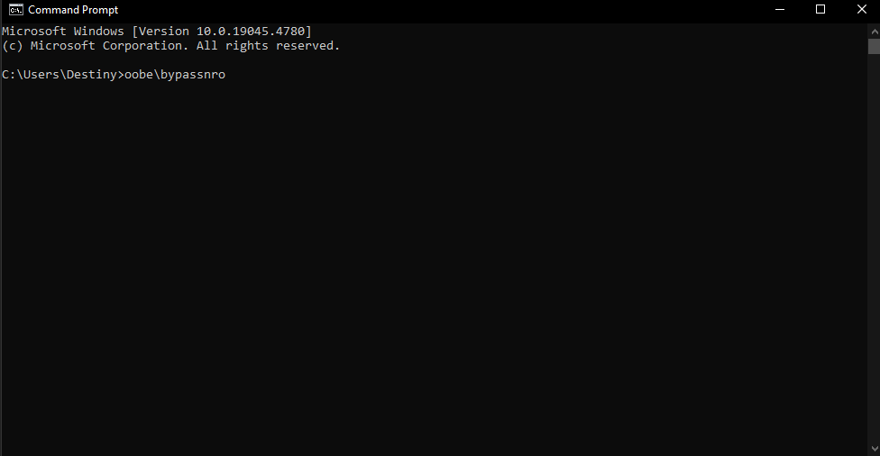

There is one other way to disconnect from the Internet, and that is using VirtualBox itself.

Navigate to the bottom bar of VirtualBox, and right click the 4th most icon from the left, then select “Connect Network Adapter.” This will disconnect the internet from the machine.

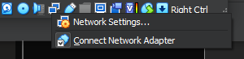

**Bypassing Windows 11 Microsoft Account:**

Windows 11 will also try to force you to make a Microsoft account. This can easily be bypassed by either typing “[no@thankyou.com](mailto:no@thankyou.com)” into the email box or clicking on “Sign in options” then “Domain join instead.”

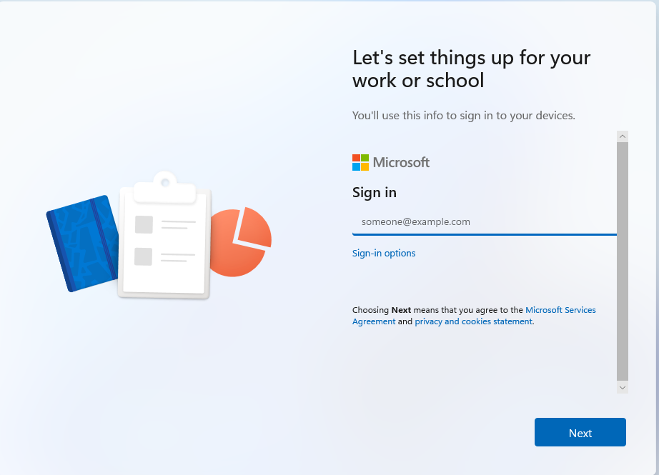

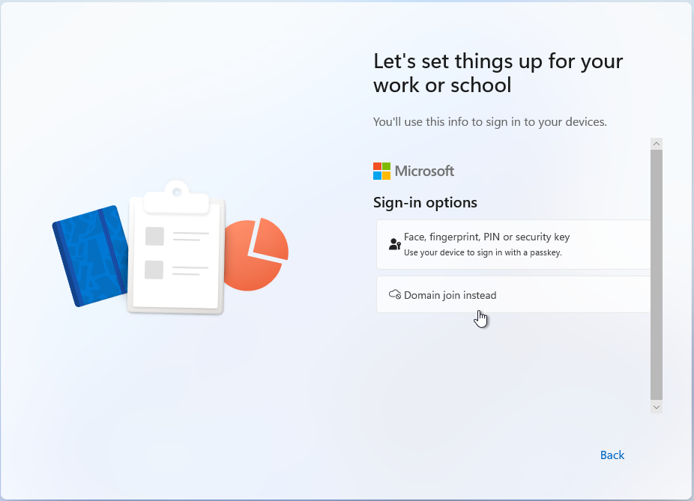

### Creating openSUSE and Ubuntu Virtual Machines

**Step 1: Create a new virtual machine for openSUSE**

If you need help creating a new virtual machine, refer to page 22; “Making a Windows 10 Virtual Machine.” This first shows you how to create a new virtual machine from scratch.

**A couple important notes:**

* *openSUSE does not need nearly as much space as Windows. The storage space will default to 8gb. Make sure to give it a little more, in my case, I am giving it 58gb.*
* *Do not check “Enable EFI”*
* *openSUSE will not give you the option to skip unattended, the installation must be done manually.*

**Step 2: Install openSUSE inside of the virtual machine**

Once you have your machine ready to go, double click on it in your Virtual Box manager to open it.

Once your machine starts, it should boot into the openSUSE installation process.

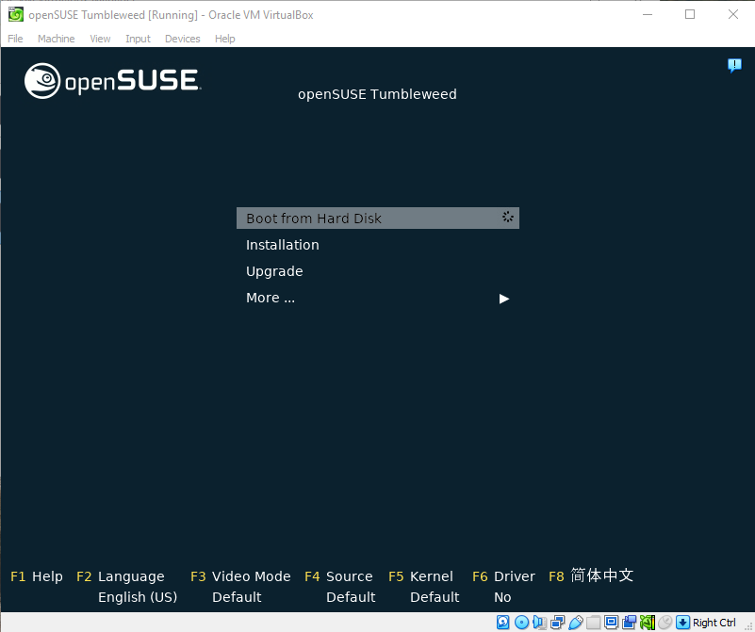

Use your arrow keys to navigate down to “Installation” and hit enter on your keyboard.

You will see a series of text on your screen, and then some loading, let it do its thing.

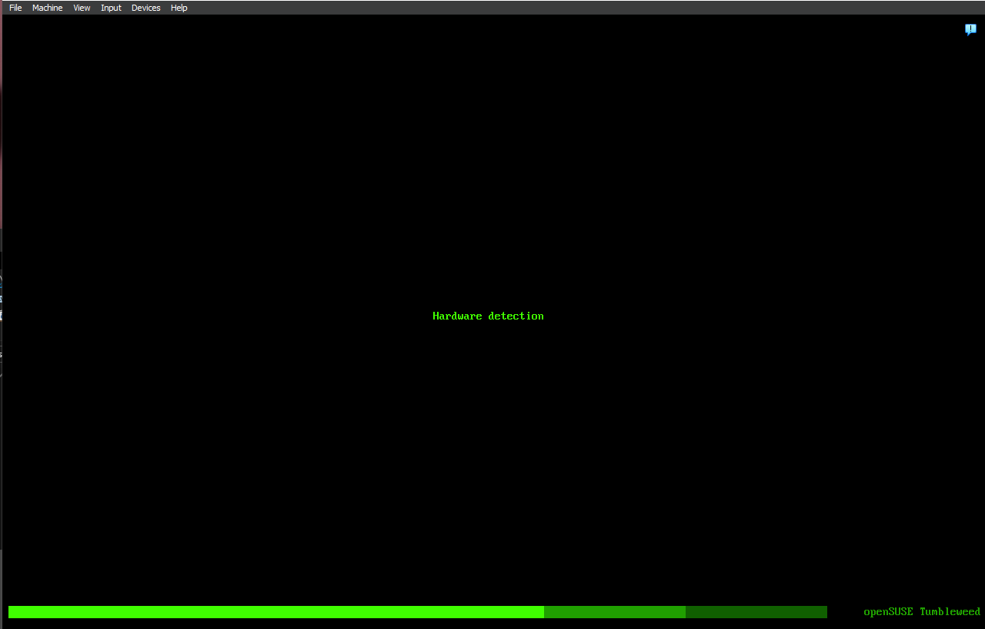

It will then initialize network configuration. It will say 100% but may not let you click on anything for a short period of time, this is normal.

A license agreement will come up next.

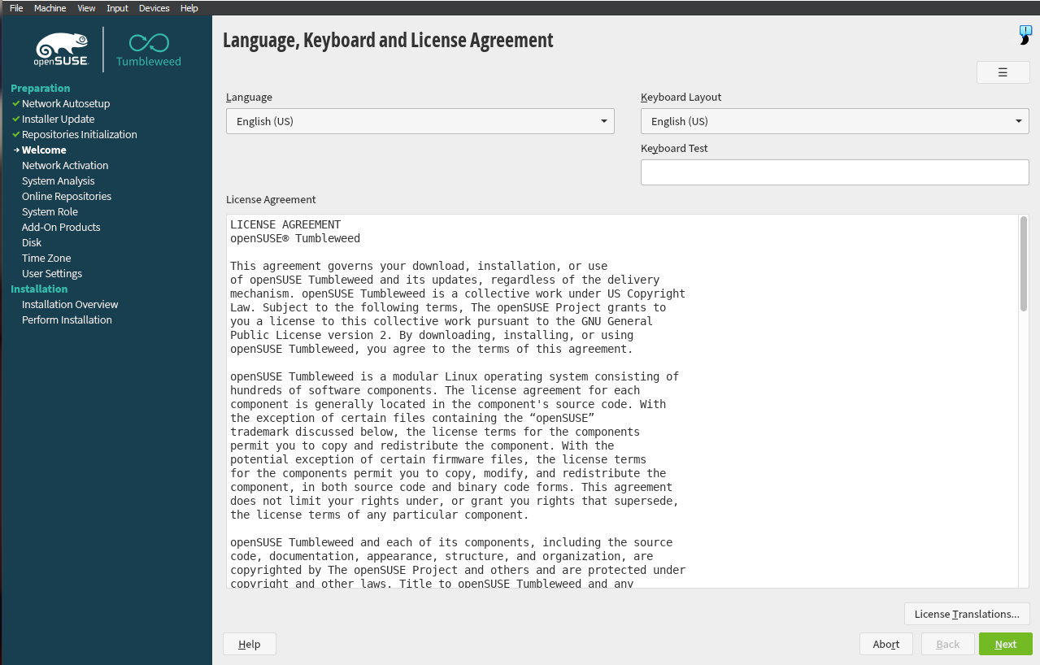

Click next in the bottom right corner.

It may ask you if you want to install repositories, say no to activating now.

Next, it will ask us what system role we want to use. I recommend choosing KDE Plasma.

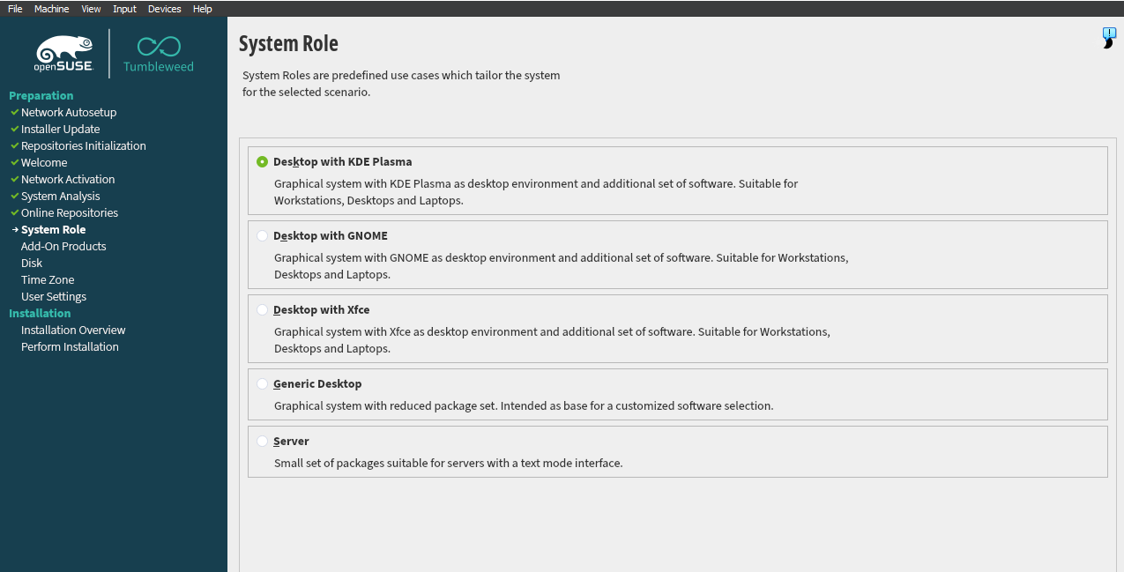

Click next, and a suggested partitioning page will come up. We’re fine with these defaults.

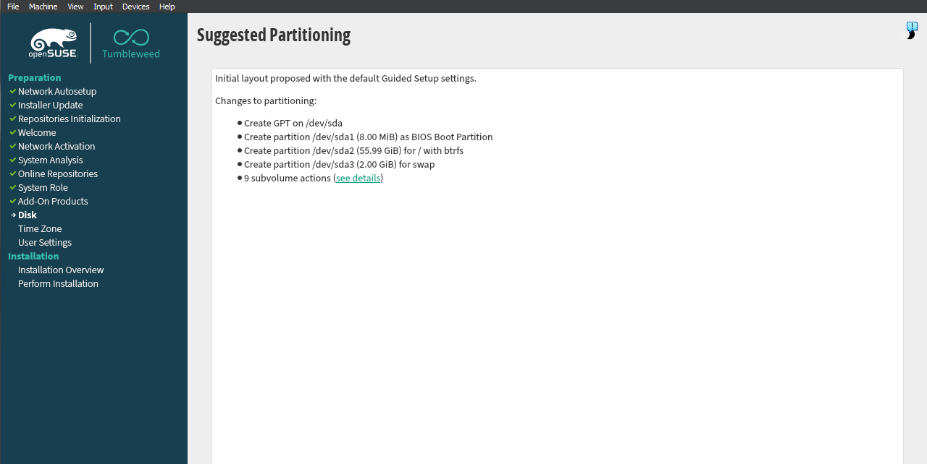

It will then ask for your region, choose your respective region, and click next.

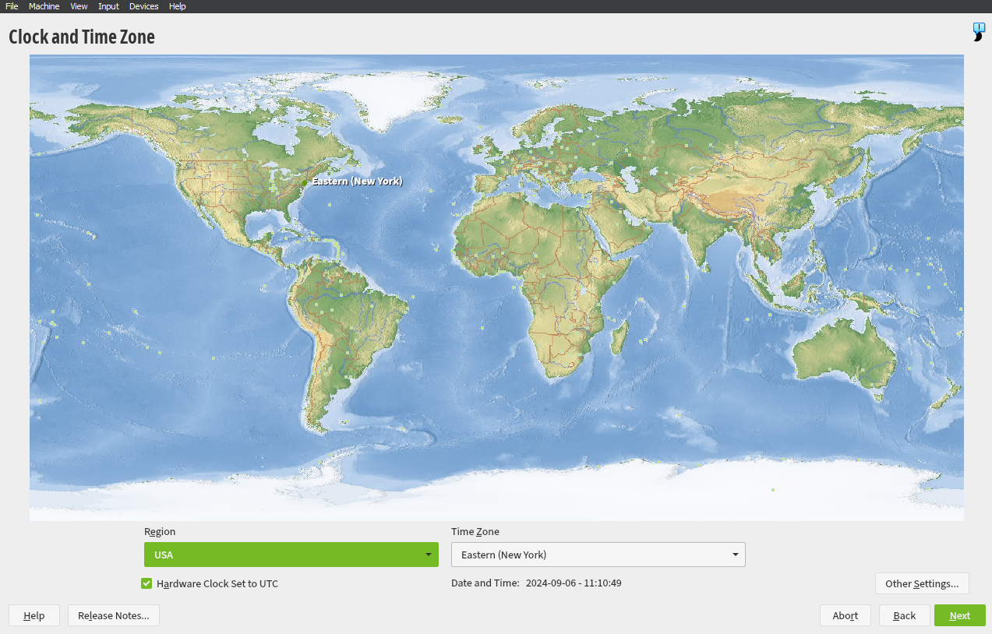

We now come to creating a user. I suggest using something like “student” for the full name field, and an easily remembered password. This is just a learning environment.

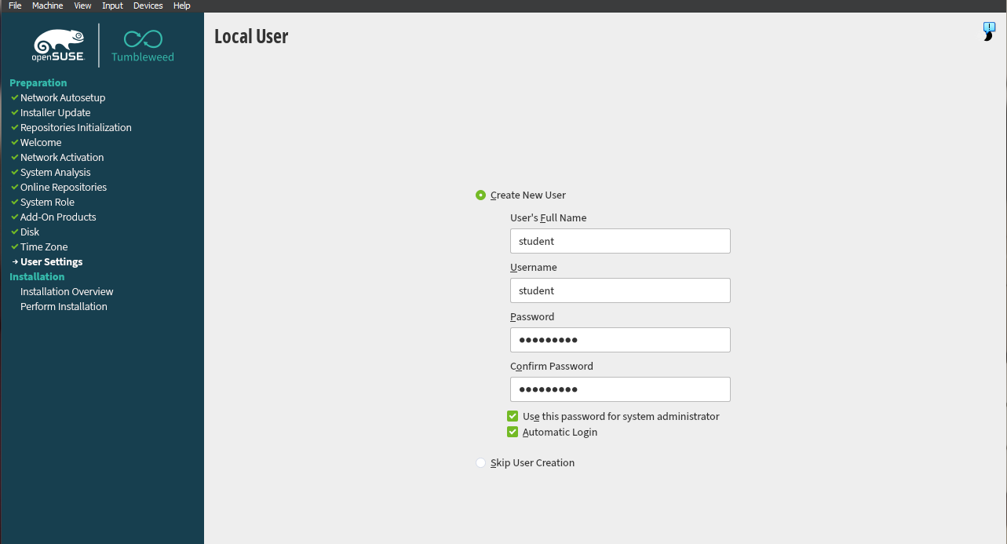

openSUSE may have a popup stating your password is too simple, click yes to using the password.

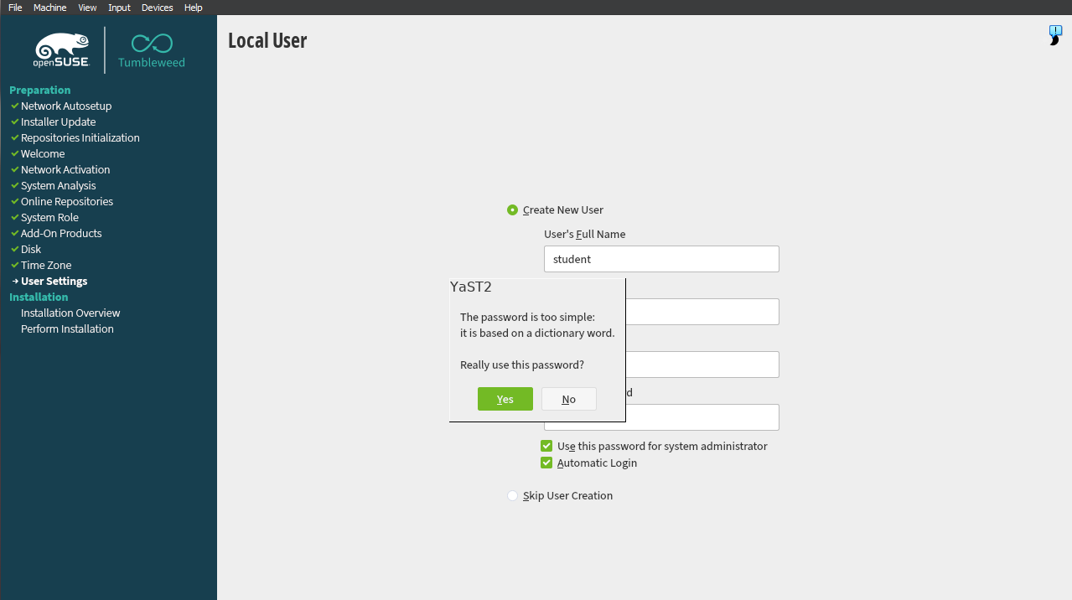

After clicking next, it will give you an installation overview. Click Install.

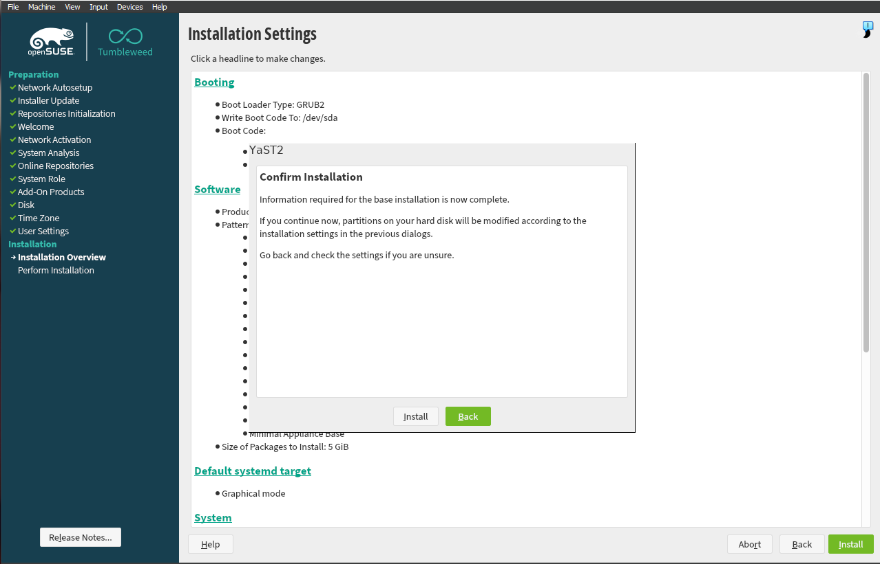

After clicking install, a popup will come up asking if you are sure you want to install. Click install again, and openSUSE will begin the final installation process.

After it is done, it will restart and take you back to the first set of options. This time, we will choose “Boot from hard disk”

Then choose “openSUSE Tumbleweed”

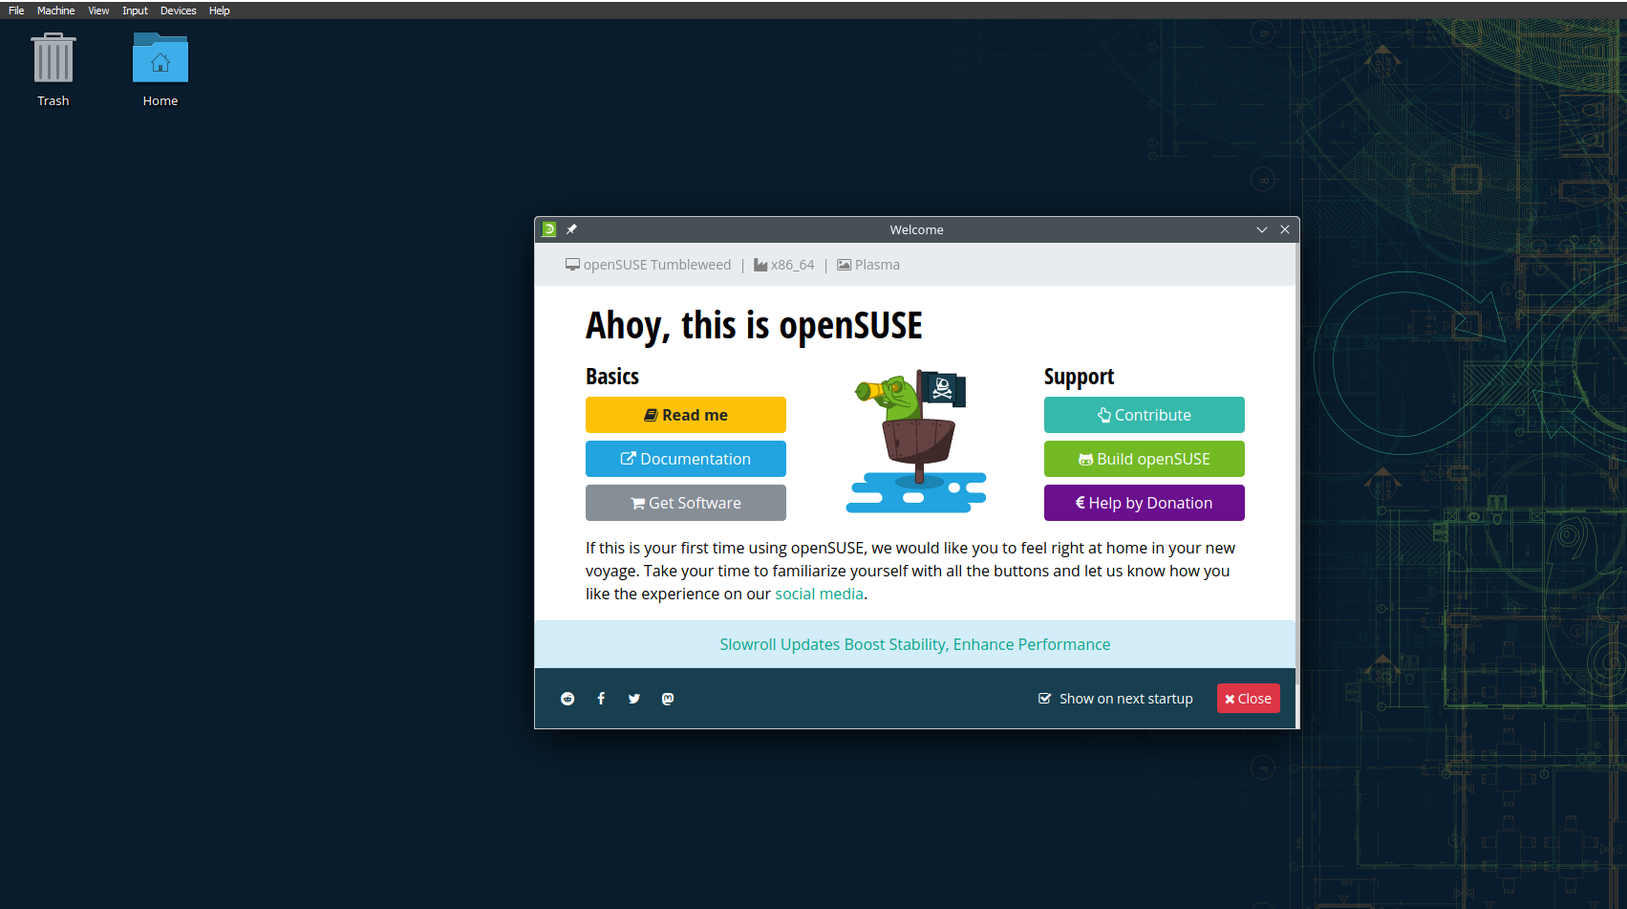

You are now inside of openSUSE!

## Windows 10 Personalization

### Using Windows 10 Registry Editor to Pause Updates

The registry editor is a database of settings for your Windows installation. Every setting you can think of for Windows is stored here. The registry editor contains very important files to your Windows installation. Be very careful when messing around with it.

In this instance, we are going to be using it to pause Window’s updates for an extended period. Usually, Windows will force you to update after a while, but there is a workaround for this.

**Step 1: Accessing The Registry Editor**

Navigate to your Windows search bar in the bottom left corner. You can type in registry editor or “regedit.”

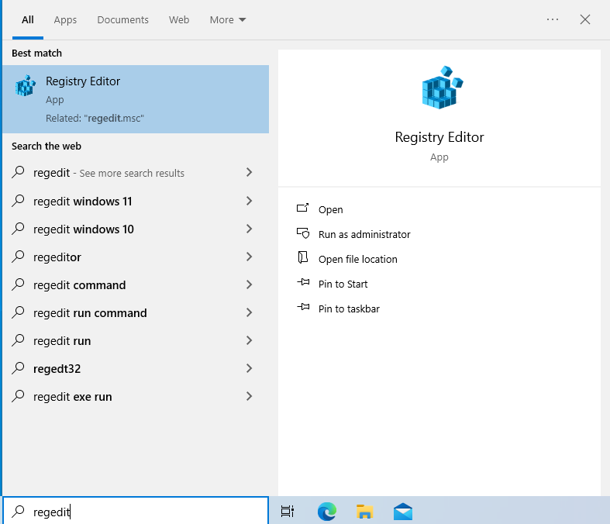

Click on the registry editor app, it will prompt you to allow it to make changes to your device. Click yes.

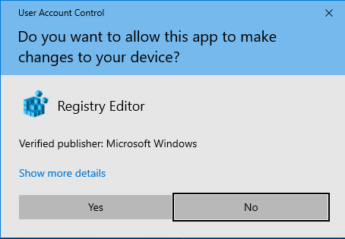

This should bring up the registry editor. It should look something like this.

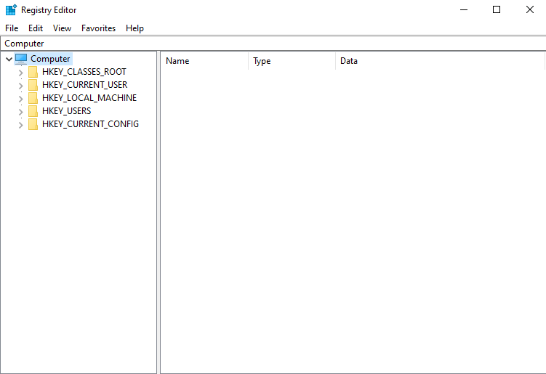

Keep in mind the folders on the left side. These are called keys. Expanding these folders will reveal more folders called subkeys.

**Step 2: Backup Windows Update Settings Key**

To get to the Windows update settings subkey, click the down arrow beside HKEY_LOCAL_MACHINE, SOFTWARE, Microsoft, WindowsUpdate, UX, Settings.

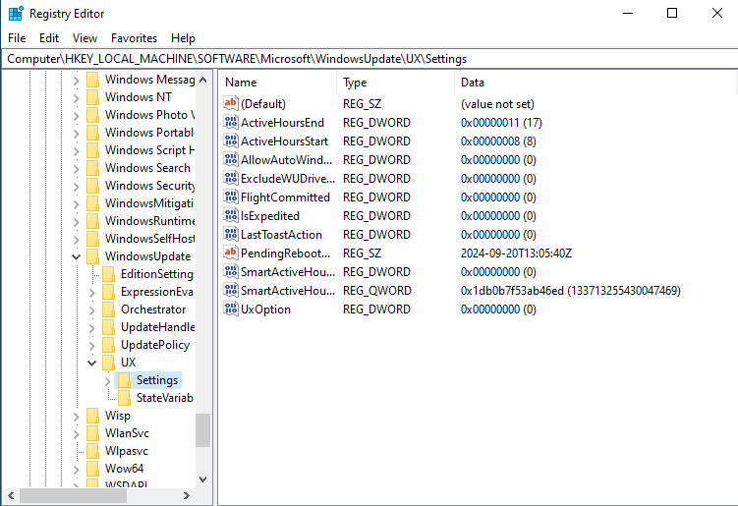

Right click on the settings subkey and choose export.

It will bring up a window that prompts you to save the key. Navigate to where you want to save it. I am naming it “WindowsUpdatePause”, so I remember what it is, and put it in a specific folder I made. Make sure “Selected branch” is selected at the bottom. If you chose all it will back up your entire registry. We are just backing up this specific key.

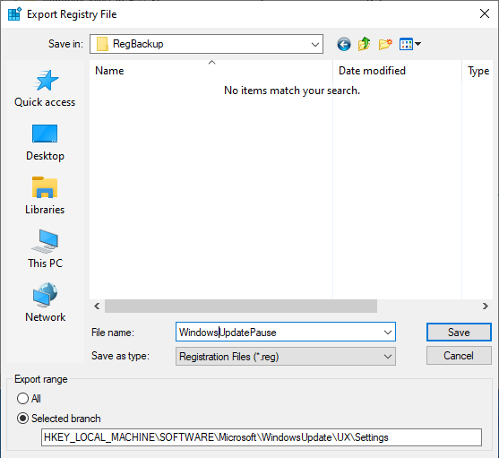

Click save.

**Step 3: Editing The Reg File**

Now we must edit the reg file. Navigate to where you saved the file. Do not double click. Right click on it and click “edit.”

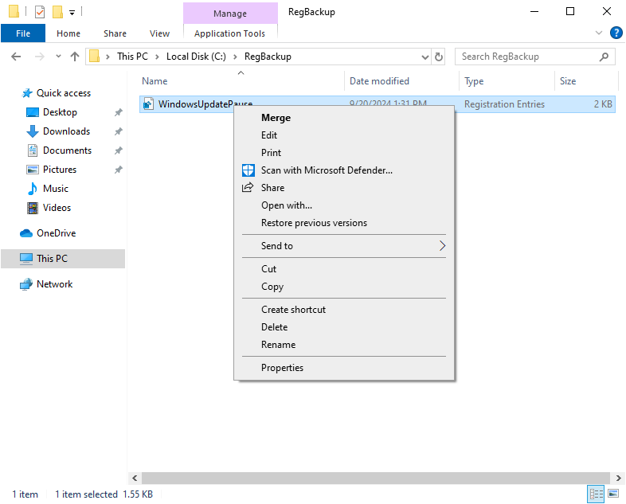

This will bring up a notepad with some text in it. Do not delete the first block of text. Right now, we only want to delete anything after the first block of text. In my case I will be deleting the two sentences at the bottom that start with “HKEY_LOCAL_MACHINE.”

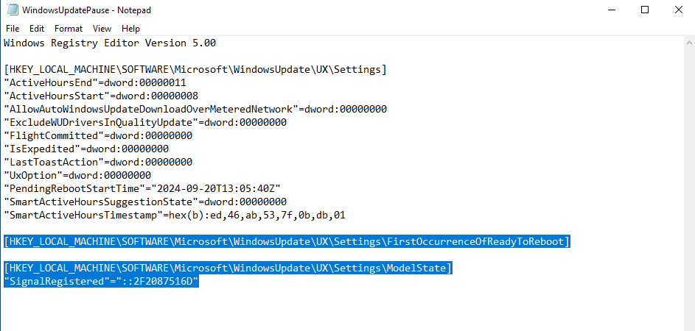

Now we want to start typing in our edits as follows:

* "PauseFeatureUpdatesEndTime"=”2024-12-20T13:05:40Z”

(For the date, you can pull this from the “PendingRebootStartTime” a little bit above. In some cases, this may not be there. If that is the case for you, please follow the exact format time and date I have here. We will be changing these anyways. Also keep in mind your date may be different. Adjust your dates accordingly.)

* "PauseFeatureUpdatesStartTime"="2024-09-19T13:05:40Z"
* "PauseQualityUpdatesStartTime"="2024-09-19T13:05:40Z"
* "PauseQualityUpdatesEndTime"="2024-12-20T13:05:40Z"
* "PauseUpdatesExpiryTime"="2024-12-20T13:05:40Z"

I went ahead and changed the times I want to use in the list above. Make sure that pause quality updates and pause feature updates start times have the exact same time, and that the time is changed to a day before the current day. Today is September 20th for me, so I changed them to September 19th.

The rest of them need a time in the future. I gave them all December 20th, 2024.

Your notepad should look like this now.

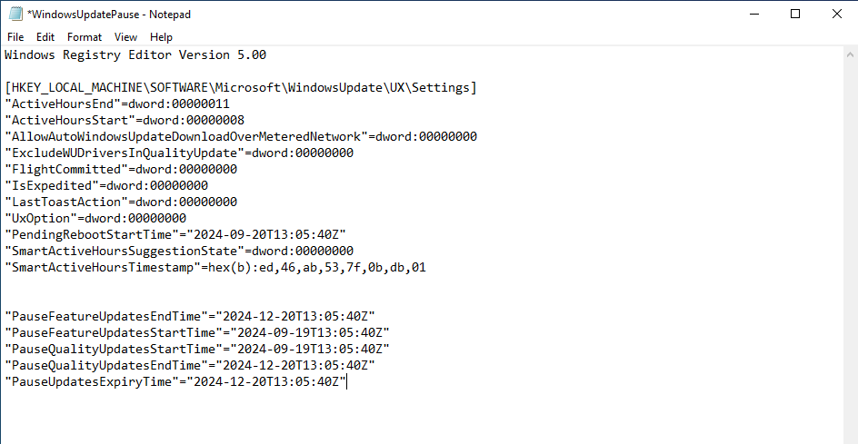

Everything under the text with the square brackets we can now get rid of except our new additions.

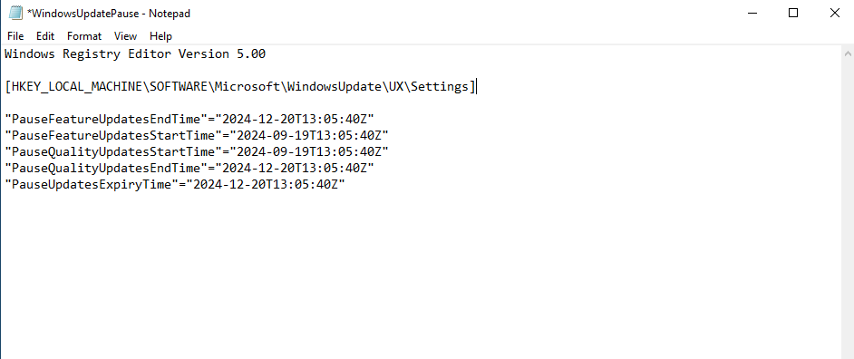

Now navigate up to file and click save.

**Step 3: Merging A Custom Reg File Into The Registry**

Navigate to the file in your file explorer and double click it, allow changes. A warning will pop up. Click yes.

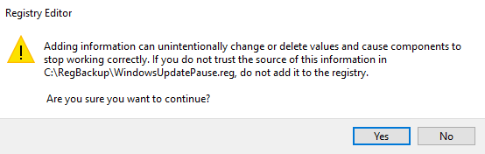

After clicking yes it will let you know the changes were added successfully.

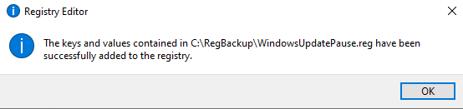

Your registry editor should now show the new entries.

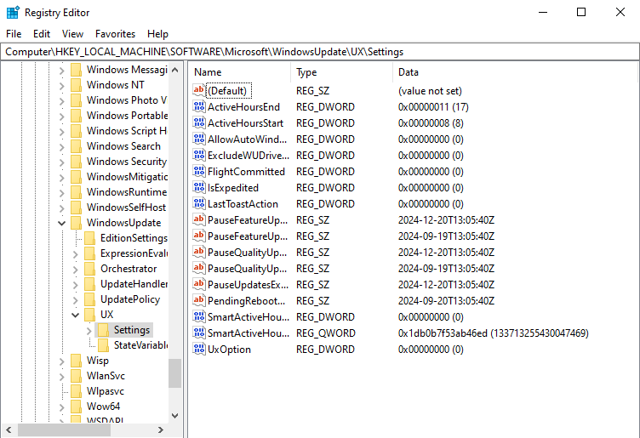

If you have anything in this file called “PendingRebootTime” right click it and click delete. I have one, so I will be deleting mine. You may or may not have one.

Now lets see if it worked! Navigate to your Windows settings, Updates and Security, then scroll down until you see “Advanced Options.”

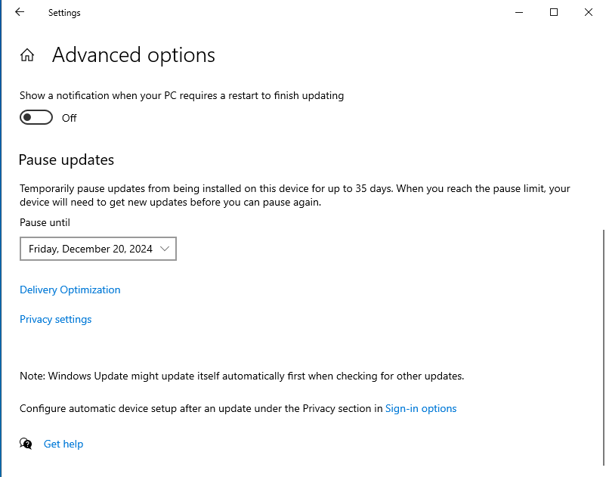

If you see a drop-down box with a date that means it worked! If you do not see one go back and edit the reg file again and make sure that you have absolutely no typos anywhere. Any typo can make it not work.

You can go into the drop-down list and choose a time up until next year.

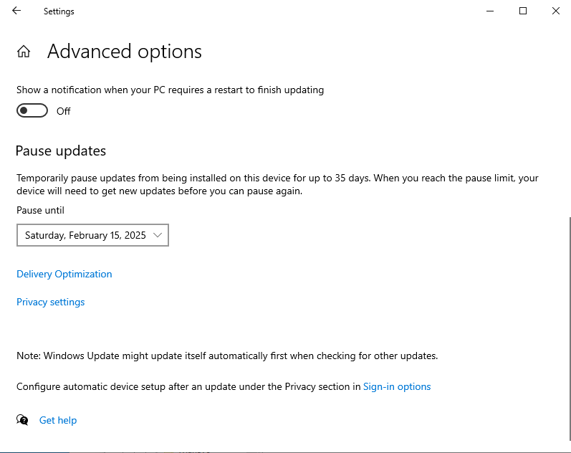

However, there is one funny thing to note. Choose a different time, and then click the back arrow, and click into advanced options again.

The list gets much longer. You can keep doing this over and over.

You now know how to pause Windows updates using the registry editor!